Create eCourse from Mass Uploaded Files

How to generate an eCourse from uploading numerous assets in a single process via an SFTP client

Author: Philip Lacey
Version: 1-0
Date: 2013-02-05

Overview

On occasion, with multiple large files to upload, an eCourse develop may prefer to upload all of the content in a single exercise. BE can then generate an eCourse around those files, by turning them into assets and appending them to dynamically generated pages in a book.

Contents
Overview 2
1. Concept Steps 3
1.1 Preparation 3
1.2 SFTP Transfer 4
1.3 SFTP Process 5
1.4 Processing uploaded files 6
1.5 The BE Process 7
2. FileZilla 9
2.1 Remote Access 9
2.2 FTP Account Settings 9
2.3 Setting up FileZilla 9

1. Concept Steps

1.1 Preparation

An author starts with a number of files they want to upload to an eCourse in BE

1.2 SFTP Transfer

Using a Secure File Transfer Protocol (SFTP) client such as FileZilla, the All n One team can provide the user with secure login details which will allow the user to upload the files. This method allows files to be queued up and guarantees upload of files.

1.3 SFTP Process

Over any time period, the files are transferred into the secure BE environment

1.4 Processing uploaded files

When all the files have been transferred up, the user logs into BE as normal

Going into:
Main Menu > eCourse Management > Book Management > Create Book from Files
A number of settings are entered

1.5 The BE Process

Upon clicking ok, BE will pull the files from the upload folder.

The system will generate an eCourse using the settings provided

The system will then take each file, in alphabetical order, convert the file to an asset and associate that asset with the page.

It will then process each file in the folder into new pages and assets. This process uses one asset per page until no assets remain.

2. FileZilla

2.1 Remote Access

Retrieving or storing of files remotely can be done a number of ways. SFTP is one of these ways.

This is usually done using a secure FTP client such as FileZilla.

http://filezilla-project.org/



2.2 FTP Account Settings

Host: 82.195.135.248
Username: client_yournamehere
Password: --will be texted separately—
Encryption: SFTP

2.3 Setting up FileZilla

After you have downloaded and installed FileZilla you will end up with a screen similar to this

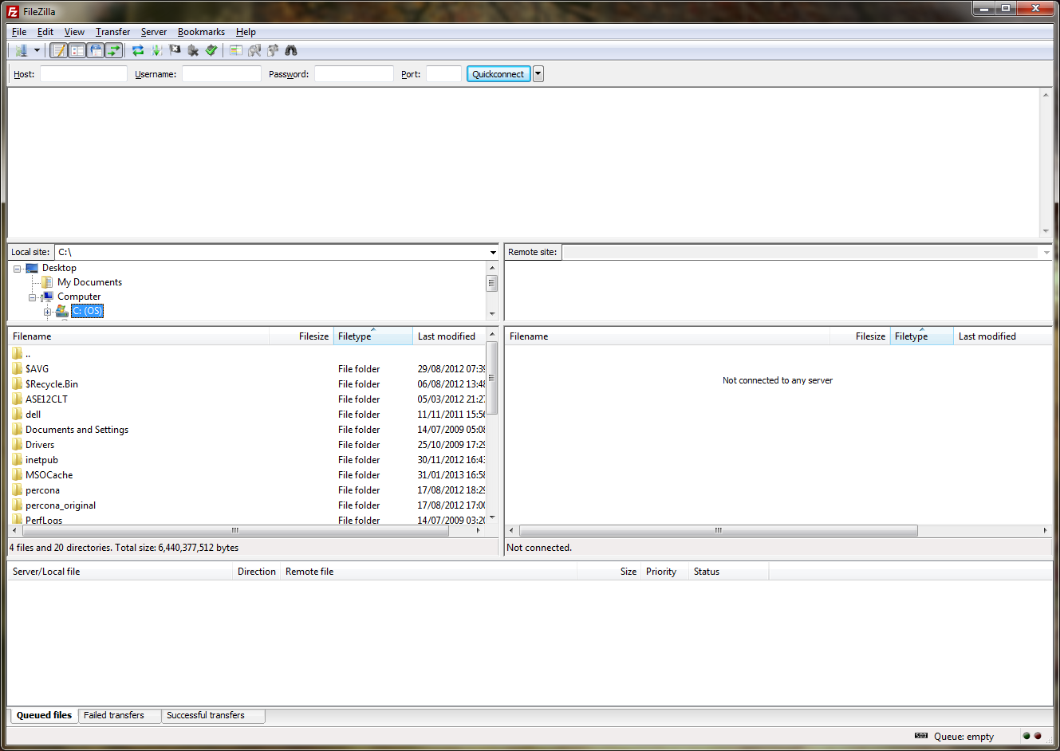

Go to File > Site Manager

Click the “New Site” button

Type in a name you will remember. In the example below we have used “AllnOne_eCourseDemo”

Then fill in the details as supplied in 2.2

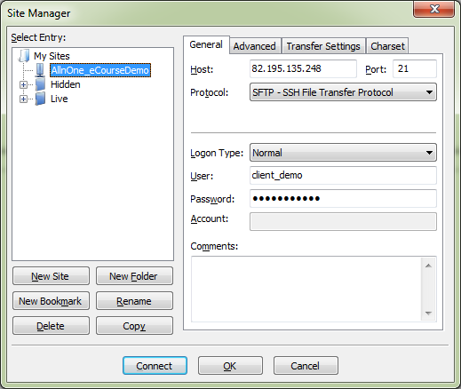

Click Connect when done

You should get a a few messages scroll up the window as follows

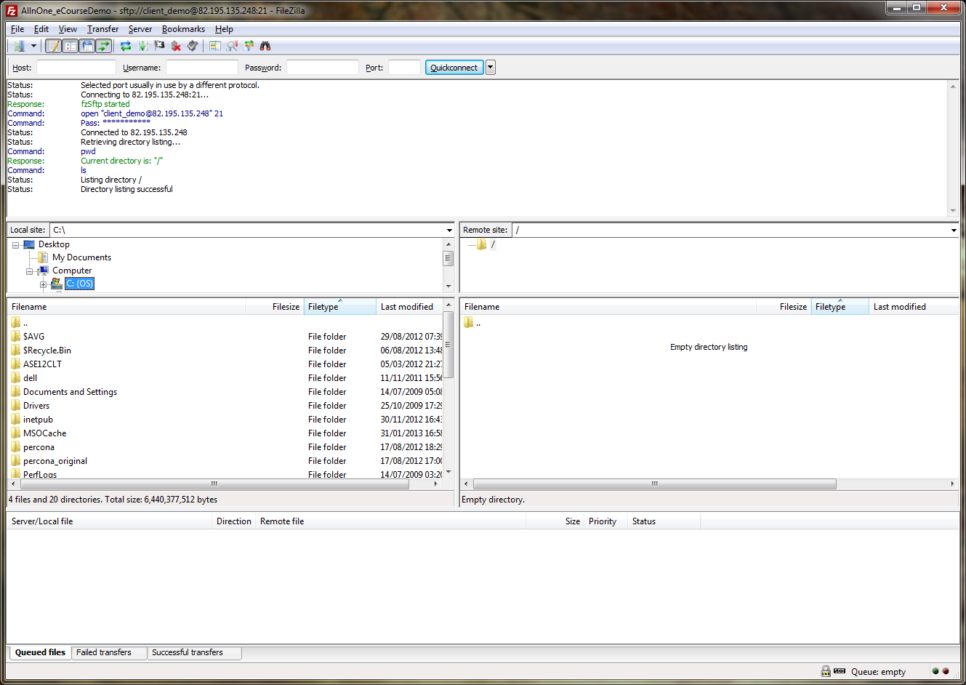

In the middle of the screen, you can drag files from your computer (the left hand two middle windows) to the remote computer (the right hand two middle windows).

You can see the files transferring and those remaining to be transferred in the bottom pane.

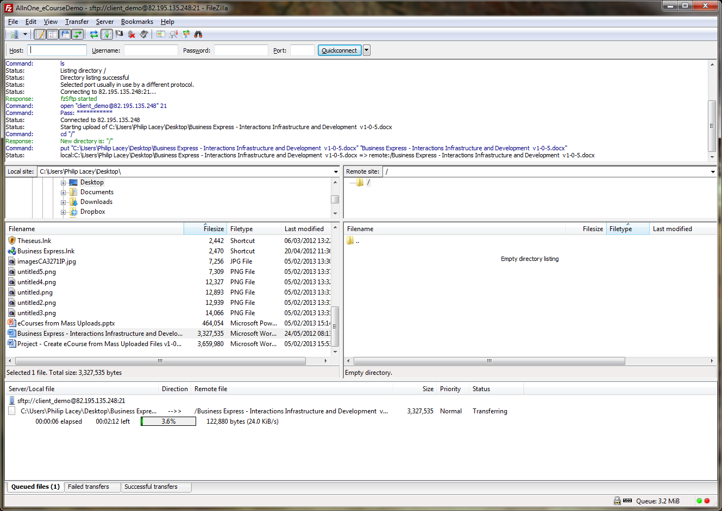

Do NOT copy folders. BE will only process files that are found.

If you have any difficulties please contact your BE System Champion or point of contact in All n One.

