Business Express

Contact Management Integration (CMI)
Application Programming Interface (API)

Version: 4-0-4
Date: 2009-08-07
Author: Philip Lacey

Page intentionally left blank

1. Introduction

1.1 Purpose of Document

This document provides an overview on how to integrate Business Express (BE) with external systems or websites.

It refers to the lookup, editing and management of data records within a contact management environment and how those processes interface with BE.

1.2 Intended Audience

The Document is aimed at developers who are designing solutions for integration of Business Express and programmers who will be integrating Business Express as part of their own solutions.

1.3 Definitions, Acronyms, Abbreviations and Clarifications

Phrase Description
API Application Programming Interface
BE Business Express
CCL Campaign Call, a contact record associated with a CDA
CDA Campaign Data, the table holding the customer info
CTI Computer Telephony Integration
HTTP HyperText Transfer Protocol
N/A Not applicable
PBX Public Branch Exchange
URL Universal Resource Locator (e.g. http://www.google.ie)

- ‘BE System’ is a single instance of the Business Express system which is uniquely identified by the client part of it’s URL e.g
https://ww3.allnone.ie/client/client_demo/main/login.asp

- ‘BE Client’ refers to the company who is renting the BE system

- A ‘BE Log in’, refers to an individual user for the BE Client

1.4 Revision History

Version | 4-0-4
Date | 2011-07-13
Author | Philip Lacey
Modifications | Addition of the Excel auto loading functionality

Version | 4-0-3
Date | 2011-06-23
Author | Philip Lacey
Modifications | BER6 Update and Review  Table of Contents converted to clickable menu system  Documented the eCourse and Conference Centre redirects

Version | 4-0-2
Date | 2011-03-06
Author | Philip Lacey
Modifications | Correction to documentation of Data Profiling Report functionality 7.3.10

Version | 4-0-1
Date | 2011-02-28
Author | C Thomson
Modifications | Document review

Version | 4-0-0
Date | 2011-02-24
Author | Philip Lacey
Modifications | Document layout review  Functional revision  Addition of Data Profiling and XML Load functionality

1.5 Contents

1. Introduction 3
1.1 Purpose of Document 3
1.2 Intended Audience 3
1.3 Definitions, Acronyms, Abbreviations and Clarifications 3
1.4 Revision History 4
1.5 Contents 5
2. System Overviews 7
2.1 Overview 7
2.2 Overview of the CMI API 7
2.3 Overview of BE as used for Website Integration 8
2.5 Overview of BE as used for System Integration 9
2.6 Process Flow for System Integration 10
3. System Clarifications 11
3.1 General - User Setup 11
3.2 Campaign - Understanding BE Campaign Database Structures 12
3.3 Campaign - Campaign setup for Website Integration 14
3.4 Campaign - Campaign Search Display Fields 14
3.5 SFTP Account Settings Setup 15
3.6 Campaign CMI API XML AutoLoad 16
4. Risks and Assumptions 17
4.1 Data Delivery 17
4.2 Content 17
5. Architectural Goals and Constraints 18
5.1 Goals 18
5.2 Considerations & Constraints 18
6. Quality 19
6.1 Overview 19
6.2 System Testing (Functional) 19
6.3 User Acceptance Testing 20
6.4 Programming Standards 20
6.5 Unit Testing 20
7. Function Reference 21
7.1. User Security 21
7.1.1. General Notes 21
7.2. General 22
7.2.1. Data – Server Test 22
7.2.2. Login + Appointment menu 23
7.2.3. Login + Event Space 24
7.2.4. Login + LogicFlow 25
7.2.5. Login + Task menu 26
7.2.6. Login + Testing menu 27
7.2.7. Login + eCourse Book menu 28
7.2.8. Login + eCourse Table of Contents menu 29
7.2.9. Login + eCourse Page 30
7.2.10. Login + eCourse Last Viewed Page 31
7.2.11. Login + Conference Centre 32
7.3. Campaign 33
7.3.1. Login + Data Entry 33
7.3.2. Login + Lookup 35
7.3.3. Login + Match (Exact) 36
7.3.4. Login + Match (Like) 37
7.3.5. Login + Data Management + Data Logging 38
7.3.6. Data – Campaign Structure 43
7.3.7. Data – Log Automated Contact 44
7.3.8. Data – Attach file to record (Link method) 45
7.3.9. Data – XML Auto Load 46
7.3.10. Data – Excel Auto Load 47
7.3.11. Data Profiling – Report Generation 48
7.3.12. Website 49
7.3.12.1 Website – Integration Overview 49
7.3.12.2 Website – Login Interaction 49
7.3.12.3 Website – Data Query 53
7.3.12.4 Website – Data Logging 57
Appendix A – Response Codes 63

2. System Overviews

2.1 Overview
The BE CMI API can be used to integrate with any number of external solutions. It is currently optimised to be used in one of three ways.

- As the database solution for web surveys / membership websites (Website Integration)

- As an enhanced way of logging a user in, e.g. integration with a phone system (System Integration)

- As a method of automated file loading and report generation using manual means or Windows Scheduled tasks

2.2 Overview of the CMI API

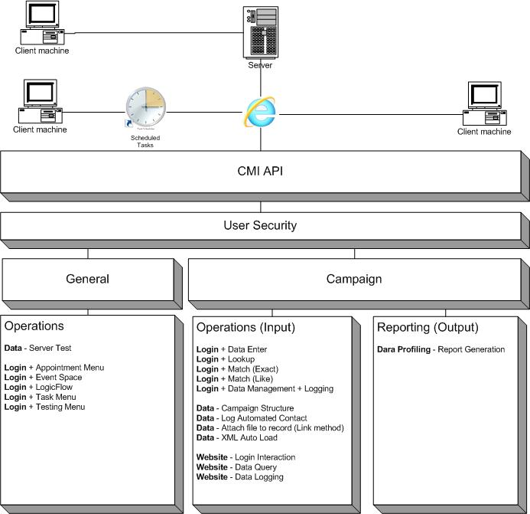

2.3 Overview of BE as used for Website Integration

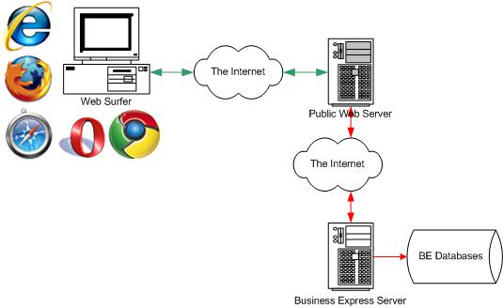

Business Express can act as the database management engine for any public / external facing website. For example, information captured in a form can be securely redirected to Business Express and stored in a campaign. Business Express can also supply data in the form of XML documents, which can be displayed as lists. Campaigns can also be used to provide simple logon verification.

Data is pushed to BE as a HTTPS POST. Data is retrieved as an XML or HTML document.

2.4 Process Flow for Website Integration

- Data is collected from the user and submitted to a processing page
- The processing page reads the submission and appends key processing data
- The new data is packaged and submitted to BE
- BE processes the data and returns a data package (XML or HTML)
- The processing page interprets the return data package and informs the user as appropriate

2.5 Overview of BE as used for System Integration

Diagram 1 : Generic Dialler Interface.

When used as part of systems integration, BE is accessed through a URL call. Any system capable of generating a URL call can, through a ‘HTTP POST’, integrate with BE. BE provides a completely self contained, web based interface for testing and to aid understanding of the functions and features available to users.

The following example of a real world setup demonstrates the implementation of BE.

For phone system based processes, the Dialler processes a ‘Calling List’. When the call is connected or picked up, two things happen simultaneously. The phone call is ‘pushed’ to an agent and a data command is sent to an agent’s machine.

There is a listening application on the agent’s machine, waiting to receive this instruction. When the listener picks up the instruction, it opens a URL. The URL is a page on the BE server. Parameters in the URL allow the dialler to pass record specific information which opens the appropriate Customer Data Record.

2.6 Process Flow for System Integration

Phone Dialler Integration

- Dialler takes a record from the calling list
- Call is answered by an agent
- Call is pushed to the agent’s phone
- Id / Phone Number is pushed to the listening application on the agent’s machine
- Agent’s machine opens a URL similar to https://ww3.allnone.ie/client/client_demo/cti/userCTI_Record.asp?intCampaign_Id=1&intCDA_1_Id=1
- BE builds the page and returns it to the agent’s machine.

Application / Intranet Integration

- Application / Intranet provides a formatted clickable link
- Agent / User clicks the link, which has auto log in to the BE system
- Destination is determined by keyword in provided parameters

3. System Clarifications

3.1 General - User Setup

Each user account that will be automatically logged in must have their External Id and External Key fields set. For Website Integration a user account is selected, as there is no differentiation between users when used on an external website.

A user must be selected against whom to log the records and perform searches. This is done using the System Access Management module inside Business Express. On every users account is an External System Id and External System Key field. Here the username and password used for external logging in is entered. (See the training videos in the System Access Management module for further details if required).

The IP address that the user / automated server may access from must also be set. This allocation can be done individually or as a group. (See the training videos in the System Access Management module on how to do this).

The user will also need appropriate permission to access the campaign. This is done using Main Menu -> Campaign Management -> Security Manager. Training videos on this are available in Business Express.

3.2 Campaign - Understanding BE Campaign Database Structures

Some understanding of BE campaign structures is required in order to use the CTI interface correctly when working with Campaign Solutions.

Campaigns can only be created using the BE interface and each campaign has an id number, incrementally starting from 1, for each client system. Each campaign in BE uses a number of tables to record data and the key table is the data table. Table field names are created automatically and cannot be changed. Please see the Campaign Management Module video based training for more information on how to create a campaign, and the elements involved.

In the BE interface, ‘Field Mapping’ is the process of creating user friendly field names, e.g. Firstname instead of strCDA_1_field_1_1, which make the system easier to use. The API requires a programmer to use the actual table names. Again video based training in the BE system explains Field Mapping.

Please use
https://ww3.allnone.ie/client/client_demo/main/login.asp
To login to the BE Demo system

When a campaign is built, a table called CDA_X (where X is the id of the campaign) is also created. Using the function calls detailed in section 3 of this document, each of the fields in the table can be seen. The Demo Campaign used in all these examples has the following layout

‘intCDA_X_Id’ is the internal id record for every data record added to the system. This id number is created by BE.

‘strCDA_X_’ is a non displayed field that can be used for storing numeric or alphanumeric ids from other systems.

Since each campaign is different, the phone number field could have any name. However in the example used, strCDA_1_field_1_5 is the work phone number field. The system will perform a lookup on a field or a combination of fields, and convert the passed parameters to the CDA_Id. If more than one field is matched the system defaults to the lowest Id. With this in mind it is important that unique field combinations are used in the lookup.

Table 1 : Campaign 1 Structure
Field | Type | Null | Key | Default | Field
intCDA_1_Id | int(10) unsigned zerofill | NO | PRI |  | Id
strCDA_1_field_0_0 | text | YES |  |  | Section Header - Customer Info
strCDA_1_field_0_1 | text | YES |  |  | Title
strCDA_1_field_1_1 | text | YES |  |  | Firstname
strCDA_1_field_2_1 | text | YES |  |  | Initial
strCDA_1_field_3_1 | text | YES |  |  | Surname
strCDA_1_field_0_5 | text | YES |  |  | Home Phone
strCDA_1_field_1_5 | text | YES |  |  | Work Phone
strCDA_1_field_2_5 | text | YES |  |  | Mobile Phone
strCDA_1_field_0_8 | text | YES |  |  | Address 1
strCDA_1_field_1_8 | text | YES |  |  | Address 2
strCDA_1_field_2_8 | text | YES |  |  | Address 3
strCDA_1_field_3_8 | text | YES |  |  | Post Code
strCDA_1_field_4_8 | text | YES |  |  | Country
strCDA_1_field_0_13 | text | YES |  |  | Section Header – Questions
strCDA_1_field_0_14 | text | YES |  |  | Favourite Colour
strCDA_1_field_0_15 | text | YES |  |  | Satisfied with life
strCDA_1_field_0_16 | text | YES |  |  | Favourite Things
strCDA_1_field_0_17 | text | YES |  |  | Favourite transport
strCDA_1_field_0_18 | text | YES |  |  | Other info
strCDA_1_ | text | YES |  |  | Future expansion
strCDA_1_Status | text | YES | MUL |  | Status
strCDA_1_Comments | text | YES | MUL |  | Comments
intCDA_1_NoOfAttempts | int(10) | YES |  | 0 | Number of Attempts
intCDA_1_StaffId | int(10) | YES |  | 0 | Staff Id
strCDA_1_LastDateTime | datetime | YES |  |  | Last contact date and time

3.3 Campaign - Campaign setup for Website Integration

For a campaign to be accessible externally it must be made available externally as well as being in-date and active. These options are available in Campaign Management. The ‘Externally Available’ option only applies for functionality where BE is used with external website integration.

If BE is being used for systems integration this option does not need to be set since, as the user is logged into the BE system, data does not leave BE.

For the campaign to be externally available:
Main Menu -> Campaign Management -> Campaign Manager -> Campaign Edit -> Select your campaign -> Scroll down to the security section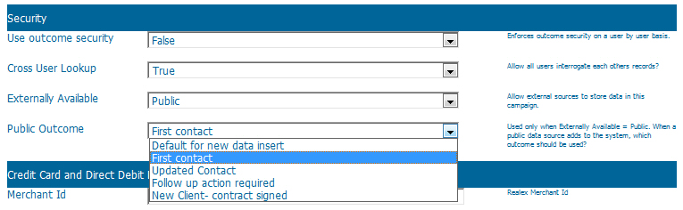

The ‘Externally Available’ must be set to ‘Public’, as it will default to ‘Private’. The default ‘Public Outcome’ must also be set.

These fields will not appear during ‘Campaign – Add’ process only ‘Campaign – Edit’.

3.4 Campaign - Campaign Search Display Fields

Since a campaign usually requires the field to match on to be specified, Generic Start Point will drop the user to campaign selection. At this point it’s still not possible to tell which field to search on. Each campaign must therefore have a specified field on which to search. This is done in the campaign details screen when creating or editing a campaign. E.g. Main Menu -> Campaign Management -> Campaign Manager -> Campaign – Search Display Fields

3.5 SFTP Account Settings Setup

BE supports the retrieval and depositing of files via SFTP to client SFTP servers. The management and availability of external SFTP services is not part of the BE service.

An SFTP server’s details are logged using System Access Management -> System Management -> FTP Settings Add and Edit functions.

These SFTP settings are then available for the pulling of data files for use in auto loading of data, or in pushing generated outputs for client retrieval. There is a dedicated SFTP testing system to ensure the username, password and other SFTP settings entered are correct and working.

3.6 Campaign CMI API XML AutoLoad

The setting to utilise this function will only appear after a campaign has been built. When editing a campaign the following section will appear.

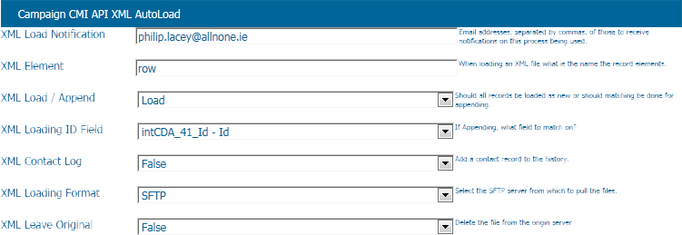

XML Load Notification - Email addresses, separated by commas, of those to receive notifications on this process being used

XML Element - When loading an XML file what is the name the record elements. This will be the name of each data element, e.g. record or row

XML Load / Append - Should all records be loaded as new or should matching be done for appending. If ‘Load’ is chosen, all records will be added as new records. Append will try to match using details from the subsequent fields

XML Loading ID Field - If Appending, what field to match on? If no match found, new record assumed. If match found details updated where field matching occurs.

XML Contact Log - Add a contact record to the history

XML Loading Format - Select the SFTP server from which to pull the files

XML Leave Original - Delete the file from the origin server

4. Risks and Assumptions

There are a number of considerations associated with integrating BE with a custom external system, based on the information available to date.

4.1 Data Delivery

The method of communication in this project is via HTTP & HTTPS. Due to the inability of the protocol to guarantee delivery, systems have been put in place to allow for validation and re-request of documents.

Note: All ASP page names defined in this document are case-sensitive, as are all parameters associated with the calls.

4.2 Content

BE system Date and Time Parameters must be in Universal Time Format (UTF) which is YYYY-MM-DD HH:MM:SS

Records which are loaded via the Campaign Management module will be loaded exactly as per their data file. No attempt at type conversion will be made. Date and numeric fields will be treated as text.

Where possible, BE applies ‘Trimming’ to fields, to help improve matching

We assume that all non system specific database fields will be alphanumeric with no set size limit.

When passing data via parameters for diagnostic purposes, it is advisable that all details be URL encoded; for example a space would be coded to %20. BE will translate these parameters back during processing. Generally, BE will work without URL encoding.

5. Architectural Goals and Constraints

5.1 Goals

The solution will be
• Easily accessed and intuitive
• Designed with open architecture for end-to-end integration
• Flexible but rule based
• Secure
• Standards-based
• Scalable
• Robust
• Processor and memory efficient
• Compliant with all Data Protection legislation

The design will be standards-based to enable any developer to extend the functionality and systems integration should future development be required.

5.2 Considerations & Constraints

Internet Security

Where required IP security can be added to limit requests to specified IP addresses only. Adding or changing is carried out within the System Access Management Module.

Flexible & Modular

To meet the requirement of flexibility, this solution will be developed in as component-based and modular a fashion as possible. If possible each component of the system should be developed separately and almost completely decoupled from the components on which it is dependent. Of course, this describes the classic n-tier development process.

Reliability & Performance

Performance is key. The proposed architecture will deliver the performance and scalability required for enterprise-class deployments including load balancing, connection pooling and results caching.

Implementation Language

BE implementation language is VBScript with ASP pages. Output is HTML with Javascript, where necessary, for validation. Pure systems integration will use XML or pure text responses. In all cases full documentation will be provided.

6. Quality

6.1 Overview

Testing outlined in this document is high-level. Separate testing plans are implemented when All n One and a third party developer work together on a project.

The activities outlined here represent just a few of the spectrum of tests performed to ensure that BE has the expected levels of stability and quality.

All tests are clearly defined and have an agreed objective based on a mutual understanding of the system and the clients’ requirements. Reviews and checkpoints may be re-visited during a project life, depending on the number of project phases

All activities and processes are controlled by the Project Manager who defines procedures, provides templates and guidelines for the project and will also incorporate, design and implement project specific activities.

6.2 System Testing (Functional)

System testing should not only be used to testing the functionality of the system, but must also prove that the product meets the clients’ requirements.

Function testing identifies any discrepancies between specified and actual performance and begins as soon as there is sufficient functionality for some (or all) of the identified tests to be executed. This is usually after unit and integration (development) testing have been completed.

System testing, undertaken prior to client release, should also prove that the product has an acceptable level of stability. Additional tests may be added, depending on the product and its intended use.

6.3 User Acceptance Testing

This is the final testing phase and acceptance criteria need to be agreed and documented in advance as part of the project definition.

An appropriate third party will often perform acceptance testing and evaluate the end product against the client’s requirements. It is therefore important that time is allowed for detailed feedback and response. The tester should be familiar with the intended purpose of the product.

Time scales for acceptance will vary depending on the product and individual agreements will need to be put in place regarding this process. Where other support processes are required they will be implemented depending on the type of project and contract agreements.

6.4 Programming Standards

The source in the system will be developed in accordance with the SDLC (Software Development Life Cycle) and All n One’s internal software standards which are based on industry best practice.

6.5 Unit Testing

Testing is built in to the development process, with each program element being unit-tested. This means that components are individually functional according to specification, before being amalgamated with the overall system.

7. Function Reference

7.1. User Security

7.1.1. General Notes

A demonstration system has been built on the BE server to demonstrate the use and actual returns of function calls.

All URL function calls are made through an SSL certificate and using HTTPS. Functions will work without using HTTPS but it is vital that developers use the HTTPS for data security on their own systems.

Where Business Express is used as the external website database engine, the external website will need an SSL secured form page. Data transfer to BE will be secure but to ensure continuity of security the public site should also encrypt the form taking data.

When passing data to BE, including data in the Query String of the request is a security risk, so as little data as possible should be passed in this way.

Some integration may require automated log in to BE and to facilitate this a separate security ID and matching key system has been developed. The BE Client will add this extra information to the BE log in the System Access Management module which will allow Client Dialler Desktop Agent systems to log the user into BE without the need for BE User input.

In the interests of security, IP restrictions are applied on a user by user basis, thus limiting where an automated log in can be accessed from. After each automated log in, the BE user’s security cookies are reset, causing multiple log outs if the user tries to use the system manually whilst also using the automated dialler feature.

Upcoming security measures will accommodate encrypted POST or XML contents. Putting information in the Query String is a weakness but may be the only technology available to the Client Dialler Desktop Agent, and so has been retained. Where this is the case, information should be predominantly kept in BE with key data only being passed via the Query String.

7.2. General

7.2.1. Data – Server Test
Description | This function allows a calling server to check that the BE server is available over the net and is responding to CTI commands. It can also be used for speed testing.
Parameters
Generic Function | userCTI_Alive.asp
Example Function | https://ww3.allnone.ie/client/client_demo/cti/userCTI_Alive.asp
Notes | See Appendix A for status codes.

7.2.2. Login + Appointment menu

Description | Logs the user in and redirects the user to the Appointment Menu.  If the value parameter is used the system will further redirect to the logging screen, of the Id of the calendar specified, in the “Availability / Appointment Management” section.
Parameters | user_id = The user id (See section3.1)  user_key = The user key (See section3.1)  system = The menu to redirect to  Optional  ID = The appointment to go to day view
Generic Function | userCTI_GenericEntry.asp?user_id=X&user_key=Y&system=appointment&ID=Z
Example Function | https://ww3.allnone.ie/client/client_demo/cti/userCTI_GenericEntry.asp?user_id=abc123&user_key=passkey&system=appointment
Notes | The user must be granted specific permission to access the calendar and module section.

7.2.3. Login + Event Space

Description | Logs the user in and redirects the user to the Appointment Menu.  If the ID parameter is used the system will further redirect to the day view of the Id of the calendar specified in the “Appointment Management” section.  The other parameters allows details to be set immediately saving time on user data entry.
Parameters | user_id = The user id (See section3.1)  user_key = The user key (See section3.1)  system = The menu to redirect to  Optional  ID = The appointment to go to day view  duration = A number in minutes  subject = URL encoded title of appointment  body = URL encoded details for appointment body  colour = Web Hex calendar background colour
Generic Function | userCTI_GenericEntry.asp?user_id=X&user_key=Y&system=appointment&ID=Z&duration=Z&subject=Z&body=Z&colour=Z
Example Function | https://ww3.allnone.ie/client/client_demo/cti/userCTI_GenericEntry.asp?user_id=abc123&user_key=passkey&system=eventspace&ID=Z&duration=30&subject=Test%20Subject&body=Test%20body&colour=FF0000
Notes | The user must be granted specific permission to access the calendar and module section.

7.2.4. Login + LogicFlow

Description | Logs the user in and redirects the user to the LogicFlow Menu.  If the ID parameter is used, the system will further redirect to the start page, of the Id of the flow specified.
Parameters | user_id = The user id (See section3.1)  user_key = The user key (See section3.1)  system = The menu to redirect to  Optional  ID = The LogicFlow to go to
Generic Function | userCTI_GenericEntry.asp?user_id=X&user_key=Y&system=logicflow&ID=Z
Example Function | https://ww3.allnone.ie/client/client_demo/cti/userCTI_GenericEntry.asp?user_id=abc123&user_key=passkey&system=logicflow&ID=1
Notes | The user must be granted specific permission to access the Logic Flow and module section.

7.2.5. Login + Task menu

Description | Logs the user in and redirects the user to the Task Management Menu.  If the ID parameter is used the system will further redirect to logging a new task in the specified project.
Parameters | user_id = The user id (See section3.1)  user_key = The user key (See section3.1)  system = The menu to redirect to  Optional  ID = The project to go to
Generic Function | userCTI_GenericEntry.asp?user_id=X&user_key=Y&system=task&ID=Z
Example Function | https://ww3.allnone.ie/client/client_demo/cti/userCTI_GenericEntry.asp?user_id=abc123&user_key=passkey&system=task&ID=1
Notes | The user must be granted specific permission to access the project and module section.

7.2.6. Login + Testing menu

Description | Logs the user in and redirects the user to the Testing Centre Menu.  If the ID parameter is used the system will further redirect to taking the test of the specified ID.
Parameters | user_id = The user id (See section3.1)  user_key = The user key (See section3.1)  system = The menu to redirect to  Optional  ID = The project to go to
Generic Function | userCTI_GenericEntry.asp?user_id=X&user_key=Y&system=testing&ID=Z
Example Function | https://ww3.allnone.ie/client/client_demo/cti/userCTI_GenericEntry.asp?user_id=abc123&user_key=passkey&system=testing&ID=1
Notes | The user must be granted specific permission to access the test and module section.

7.2.7. Login + eCourse Book menu

Description | Logs the user in and redirects the user to the eCourse Book listing for the user.
Parameters | user_id = The user id (See section3.1)  user_key = The user key (See section3.1)  system = The menu to redirect to
Generic Function | userCTI_GenericEntry.asp?user_id=X&user_key=Y&system=ecoursebook
Example Function | https://ww3.allnone.ie/client/client_demo/cti/userCTI_GenericEntry.asp?user_id=abc123&user_key=passkey&system=ecoursebook
Notes | The user must be granted specific permission to access the eCourse menu. Only books the user has been given read or edit permission to will be displayed.

7.2.8. Login + eCourse Table of Contents menu

Description | Logs the user in and redirects the user to the Table of Contents for the supplied Book Id.
Parameters | user_id = The user id (See section3.1)  user_key = The user key (See section3.1)  system = The menu to redirect to  Optional  ID = The book to go to
Generic Function | userCTI_GenericEntry.asp?user_id=X&user_key=Y&system=ecoursetoc&ID=Z
Example Function | https://ww3.allnone.ie/client/client_demo/cti/userCTI_GenericEntry.asp?user_id=abc123&user_key=passkey&system=ecoursetoc&ID=1
Notes | The user must be granted specific permission to access the eCourse menu and the specified Book

7.2.9. Login + eCourse Page

Description | Logs the user in and redirects the user to the specified eCourse page.
Parameters | user_id = The user id (See section3.1)  user_key = The user key (See section3.1)  system = The menu to redirect to  Optional  ID = This is the reference code supplied on the eCourse page.
Generic Function | userCTI_GenericEntry.asp?user_id=X&user_key=Y&system=ecoursepage&value=X-Y-Z
Example Function | https://ww3.allnone.ie/client/client_demo/cti/userCTI_GenericEntry.asp?user_id=abc123&user_key=passkey&system=ecoursepage&value=1-1-1
Notes | The user must be granted specific permission to access the eCourse menu and to the specified Page.

7.2.10. Login + eCourse Last Viewed Page

Description | Logs the user in and redirects the user to the last viewed eCourse page or the Book menu if no previous history is found.
Parameters | user_id = The user id (See section3.1)  user_key = The user key (See section3.1)  system = The menu to redirect to
Generic Function | userCTI_GenericEntry.asp?user_id=X&user_key=Y&system=ecourselastview
Example Function | https://ww3.allnone.ie/client/client_demo/cti/userCTI_GenericEntry.asp?user_id=abc123&user_key=passkey&system=ecourselastview
Notes | The user must be granted specific permission to access the eCourse menu.

7.2.11. Login + Conference Centre

Description | Logs the user in and redirects the user to the specified Conference.
Parameters | user_id = The user id (See section3.1)  user_key = The user key (See section3.1)  system = The menu to redirect to  Optional  ID = This is the ID of the Conference Room
Generic Function | userCTI_GenericEntry.asp?user_id=X&user_key=Y&system=confcentre&ID=Z
Example Function | https://ww3.allnone.ie/client/client_demo/cti/userCTI_GenericEntry.asp?user_id=abc123&user_key=passkey&system=confcentre&ID=1
Notes | The user must be granted specific permission to access the Conference Centre - Conversations menu and to the specified Conference.

7.3. Campaign

7.3.1. Login + Data Entry

Description | This function is specifically to allow unattended log-ins. It also accommodates the situation where either no campaign has been selected or the phone system is unable to determine which campaign the data is to be passed to.  The page will perform an unattended login with security permissions set appropriately. The passed key data will be appended to a campaign selection screen, from which the user can select the campaign to process on.
Parameters | user_id = The user id (See section3.1)  user_key = The user key (See section3.1)  ID = The campaign to go to
Generic Function | userCTI_GenericStart.asp?user_id=X&user_key=Y&ID=Z
Example Function | https://ww3.allnone.ie/client/client_demo/cti/userCTI_GenericStart.asp?user_id=abc123&user_key=passkey&ID=1
Notes | The user must be granted specific permission to access the campaign and inbound module section.
The Data Entry Start Point process  works as follows |  | Campaign Selection process
 |  | 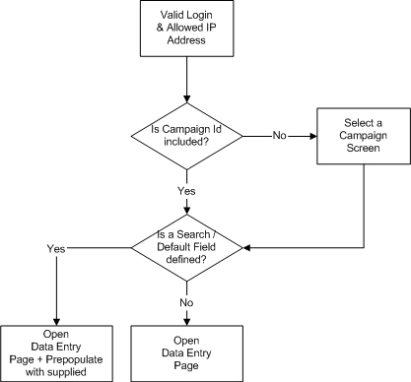

7.3.2. Login + Lookup

Description | This function facilitates unattended log ins. It also accommodates the situation where either no campaign has been selected or the phone system is unable to determine which campaign the data is to be passed to.  The page will perform an unattended login with security permissions set appropriately. The passed key data will be appended to a campaign selection screen, from which the user can select the campaign to process on.
Parameters | user_id = The user id (See section3.1)  user_key = The user key (See section3.1)  ID = The campaign to go to
Generic Function | userCTI_Lookup.asp?user_id=X&user_key=Y&ID=Z
Example Function | https://ww3.allnone.ie/client/client_demo/cti/userCTI_Lookup.asp?user_id=abc123&user_key=passkey&ID=1
Notes | The user must be granted specific permission to access the campaign and inbound module section.

The Lookup Start Point process  works as follows | Campaign Selection process

7.3.3. Login + Match (Exact)

Description | This is the primary function of CTI. By passing a unique Id or, for example, a unique phone number, the system will look up the record and display all the details on the agents PC.  There are a number of extra parameters that can be used to accelerate the process because the more information provided by parameter, the fewer database look-ups needed.  The system will automatically bounce the user’s browser to the right page in the system, either inbound or outbound section.
Parameters | user_id = The user id (See section3.1)  user_key = The user key (See section3.1)  ID = The campaign to go to  strField_Name = The campaign field name to match to  Optional  Any of the campaign fields : Any field name in the CDA table  blValidation : Enable/Disable validation
Generic Function | userCTI_Record.asp?user_id=X&user_key=Y&ID=Z&strField_Name=Value
Example Function | https://ww3.allnone.ie/client/client_demo/cti/userCTI_Record.asp?user_id=abc123&user_key=passkey&ID=1&strCDA_1_field_1_5=014294000
Notes | The user must be granted specific permission to access the campaign and inbound module section.

7.3.4. Login + Match (Like)

Description | This function is predominantly used for inbound call record lookups. Passing parameter data of any sort, the system will look up all matching records and display a record choice system on the agents PC.  There are a number of extra parameters that can be used for speed reasons. The more information provided by parameter, the fewer database look ups need to be performed.  The system will automatically bounce the users browser to the right page in the system, either inbound, outbound questionnaire or outbound sales.
Parameters | user_id = The user id (See section3.1)  user_key = The user key (See section3.1)  ID = The campaign to go to  strField_Name = The campaign field name to match to  Optional  Any of the campaign fields : Any field name in the CDA table  blValidation : Enable/Disable validation
Generic Function | userCTI_Lookup.asp?user_id=X&user_key=Y&ID=Z&strField_Name=Value
Example Function | https://ww3.allnone.ie/client/client_demo/cti/userCTI_Lookup.asp?user_id=abc123&user_key=passkey&ID=1&strCDA_1_field_1_5=014294000
Notes | The user must be granted specific permission to access the campaign and inbound module section.

7.3.5. Login + Data Management + Data Logging

Description | This function is specifically to allow unattended log ins, with redirect immediately into a specified campaign, whilst supporting a numerous parameter pass through.  As part of the direct log in facility of this function, the system also allows for XML document posting to facilitate integration with phone systems and other automated contact management systems. The process flow below shows the key elements of the process.
Parameters | user_id = The user id (See section3.1)  user_key = The user key (See section3.1)  system = The menu to redirect to  Optional  ID = The campaign to go to  Campaign_code = Alternative to ID  Various = Can be specified on a campaign by campaign basis
Generic Function | userCTI_GenericEntry.asp?user_id=X&user_key=Y&system=datalogging&ID=Z
Example Function | https://ww3.allnone.ie/client/client_demo/cti/userCTI_GenericEntry.asp?system=datalogging&user_id=abc123&user_key=passkey&campaign_code=CODE_001&parameterA=passedDataA&parameterB=passedDataB
Notes | The user must be granted specific permission to access the specified campaign and module section.

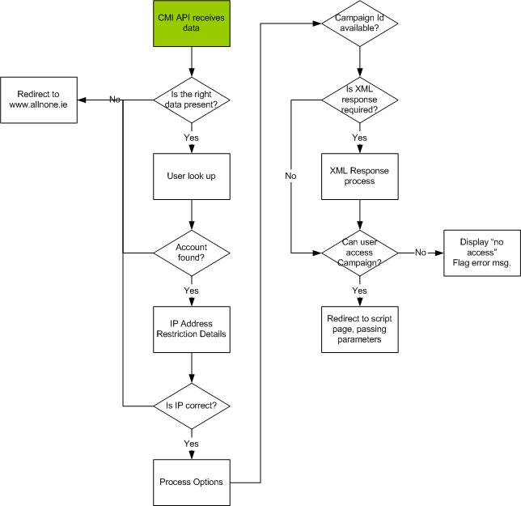

The user account management is performed as per section 2.7

Each user must be granted access to the campaign as well. Setup of campaign access is dealt with in BE using:

BE Personal Trainer -> Campaign Management -> Building a Campaign – Step 3

and

BE Personal Trainer -> Campaign Management -> Campaign security management

The XML response management is available when editing an existing campaign only.

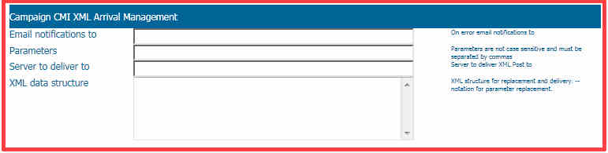

Field descriptions:

Email notifications to: As part of the XML response process if delivery fails for any reason to whom should the emails be sent?

Parameters: Parameters, separated by commas, allows Business Express know which parameters to look for and to pass through to the campaign script.

Server to deliver to: The IP address to which the XML document is sent

XML data structure: the document with replacement fields, as per the following data process management.

Sample Usage Process

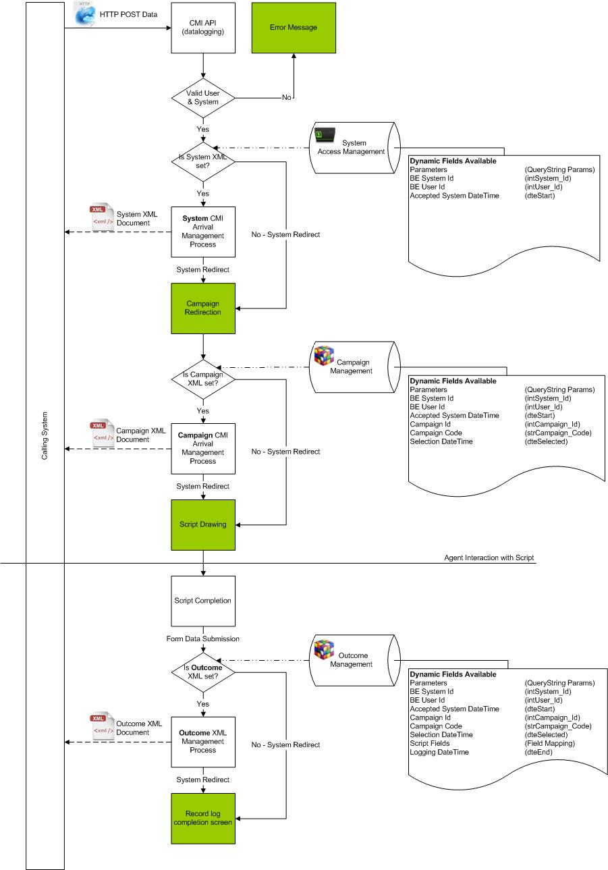

Creating a full sample test of:
=========================================
Field Values Translated Id
=========================================
System: client_demo 102
User: Test User 10
External user name: abc123
Password: passkey
Campaign: Testing campaign 23
Campaign Code: CODE_001
Parameters: parameterA,parameterB

A sample XML structure with the following XML set in the campaign details:

<data>
<record>
<strField1>--intSystem_Id--</strField1>
<strField2>--intUser_Id--</strField2>
<strField3>--dteStart--</strField3>
<strField4>--intCampaign_Id--</strField4>
<strField5>--strCampaign_Code--</strField5>
<strField6>--dteSelected--</strField6>
<strField7>--parameterA--</strField7>
<strField8>--parameterB--</strField8>
</record>
</data>

Using the URL as follows:

https://ww3.allnone.ie/client/client_demo/cti/userCTI_GenericEntry.asp?system=datalogging&user_id=abc123&user_key=passkey&campaign_code=CODE_001&parameterA=passedDataA&parameterB=passedDataB

Returns sample data to the specified server of:

<?xml version="1.0" encoding="utf-8"?>
<data>
<record>
<strField1>102</strField1>
<strField2>10</strField2>
<strField3>2010-10-11 14:30:00</strField3>
<strField4>23</strField4>
<strField5>CODE_001</strField5>
<strField6>2010-10-11 14:30:00</strField6>
<strField7>passedDataA</strField7>
<strField8>passedDataB</strField8>
</record>
</data>

7.3.6. Data – Campaign Structure

Description | This function returns the database structure of the campaign data table, enabling the developer to view the list of fields for the main lookup functions in the API. See Appendix A for status codes.
Parameters | user_id = The user id (See section3.1)  user_key = The user key (See section3.1)  ID = The campaign to display
Generic Function | userCTI_CampaignStructure.asp? user_id=X&user_key=Y&ID=Z
Example Function | https://ww3.allnone.ie/client/client_demo/cti/userCTI_CampaignStructure.asp?user_id=abc123&user_key=passkey&ID=1
Notes | The user must be granted specific permission to access the campaign.

7.3.7. Data – Log Automated Contact

Description | This function allows a dialler application to add contact history to the database, thus allowing agents see exactly how many times contact has been made in a user friendly fashion.  Date / time stamp logs are in real time to prevent tampering.
Parameters | user_id = The user id (See section3.1)  user_key = The user key (See section3.1)  ID = The campaign to display  intCDA_Id = The record Id to add to
Generic Function | userCTI_LogContact.asp?user_id=X&user_key=Y&ID=Z
Example Function | https://ww3.allnone.ie/client/client_demo/cti/userCTI_LogContact.asp?user_id=abc123&user_key=passkey&ID=1&intCDA_Id=1&strOutcome=Failed%20Contact
Notes | The user must be granted specific permission to access the campaign.  Whilst the function will accommodate the identification of a record using any combination of fields, great care must be taken to ensure limitation of matching records since all matching records will have a contact log against them.

7.3.8. Data – Attach file to record (Link method)

Description | This function allows a dialler application to add a record, the filename and the location of a recorded call. Depending on implementation, recorded calls will be stored either via a web accessible link or a local file link. The format should conform to a standard that network users should be able to access.  Web links must be preformatted with http://, https://, ftp:// or ftps://. Files that stored locally should be in the format \\Server_Name\.  Date / time stamp logs are in real time to prevent tampering.  The function will accommodate the identification of a record using any combination of fields; however, great care must be paid to ensure limitation of matching records since all matching records will have a contact log against them.
Parameters | user_id = The user id (See section3.1)  user_key = The user key (See section3.1)  ID = The campaign to display  intCDA_Id = The record Id to add to  strFilename = The URL to link to
Generic Function | userCTI_LogRecording.asp?user_id=X&user_key=Y&ID=Z&strField_Name=Value&strFilename=Outcome
Example Function | https://ww3.allnone.ie/client/client_demo/cti/userCTI_LogRecording.asp?user_id=abc123&user_key=passkey&ID=1&intCDA_1_Id=1&intCDA_1_Id=1&strFilename=http://ww3.allnone.ie/images/recording1.wav
Notes | The user must be granted specific permission to access the campaign.  Whilst the function will accommodate the identification of a record using any combination of fields, great care must be taken to ensure limitation of matching records since all matching records will have a contact log against them.

7.3.9. Data – XML Auto Load

Description | Where a campaign has been set up to process an XML data file with pre-mapped fields, the loading / appending of the data can be automated. This function allows the data to be automatically processed.  An SFTP setup must be configured, so a download can be performed and the resulting download automatically processed. See section 3.5 for SFTP setup.  Options for this setup are covered in section 3.6
Parameters | user_id = The user id (See section3.1)  user_key = The user key (See section3.1)  ID = The campaign to process
Generic Function | userCTI_XMLAutoLoad.asp?user_id=X&user_key=Y&ID=Z
Example Function | https://ww3.allnone.ie/client/client_demo/cti/userCTI_XMLAutoLoad.asp?user_id=abc123&user_key=passkey&ID=1
Notes | The user must be granted specific permission to access the campaign.  Whilst the function will accommodate the identification of a record using any combination of fields, great care must be taken to ensure limitation of matching records since all matching records will have a contact log against them.

7.3.10. Data – Excel Auto Load

Description | Where a campaign has been set up to process an Excel data file with pre-mapped fields, the loading / appending of the data can be automated. This function allows the data to be automatically processed.  An SFTP setup must be configured, so a download can be performed and the resulting download automatically processed. See section 3.5 for SFTP setup.  Options for this setup are covered in section 3.6
Parameters | user_id = The user id (See section3.1)  user_key = The user key (See section3.1)  ID = The campaign to process
Generic Function | userCTI_XMLAutoLoad.asp?user_id=X&user_key=Y&ID=Z
Example Function | https://ww3.allnone.ie/client/client_demo/cti/userCTI_XMLAutoLoad.asp?user_id=abc123&user_key=passkey&ID=1
Notes | The user must be granted specific permission to access the campaign.  Whilst the function will accommodate the identification of a record using any combination of fields, great care must be taken to ensure limitation of matching records since all matching records will have a contact log against them.

7.3.11. Data Profiling – Report Generation

Description | Data Profiling allows for more extensive custom reports to be generated from campaign data. To facilitate scheduled reporting and the running of large reports out of hours, reports can be initiated through this API.  Calling the report requires a user with permission to access the Data Profiling module, with permission to the “Campaign Data Reports – Using Groups” section. The user will also need to be able to access the campaign that the report is being generated against as well.  Report dates and times are relative to when the report is started. The word of which dates to use is set as part of the details of the Group.  SFTP transfer of reports is possible. See section 3.5 for SFTP setup. An SFTP setting can be applied to a Data Profiling group by editing the “FTP To Push To” setting details of the desired Campaign Group report. This can be found in Data Profiling -> Manage Groups -> Edit a Group –> Primary Details and selecting the appropriate Group report.  By manually setting up the report and confirming the details and data first and then applying the server to push to, after, the correct data and details can be established. Then using the FTP settings, the file delivery can be tested.
Parameters | user_id = The user id (See section3.1)  user_key = The user key (See section3.1)  ID = The campaign of the report  reportId = The Id of the report to be processed
Generic Function | userCTI_DataProfiling.asp?user_id=abc123&user_key=passkey&ID=123&reportId=123
Example Function | https://ww3.allnone.ie/client/client_demo/cti/userCTI_DataProfiling.asp?user_id=abc123&user_key=passkey&ID=123&reportId=123
Notes | The user must be granted specific permission to access the campaign.

7.3.12. Website

7.3.12.1 Website – Integration Overview

When using the functions in section 4.2.7 a dedicated User Account and Campaign settings must be set prior to the campaign being available externally.

7.3.12.2 Website – Login Interaction

The login function requires a submitted form in order to validate the details. Passing the details using the query string would mean no encryption at all on the username and password of users correctly logging in.

A working example of this is available at
http://www.allnone.ie/demo_login.php

This demo is linked to the Demo campaign system of BE available at
http://ww3.allnone.ie/client/client_demo/

The campaign it is linked to is Campaign 56

There are three stages to the login process.
- User fills in the form
- Form is submitted to a processing page on your server
- Processing page will add information and submit to the BE server
- BE will redirect the user to the specified landing page with a generated session id key, which is stored in the future use field of the data record.

Step 1: The form page
The lines are numbered for reference only.
Do not include the leading bullet numbers in the HTML.

- <form name=‘form1’ action=‘X’ method=‘post’>
- Username : <input type=‘text’ name=‘username’ /><br /><br />
- Password : <input type=‘password’ name=‘passkey’ /><br /><br />
- <button name=‘Button’ type=‘submit’>Log In</button>

At Line 1, X should be aimed at your processing page e.g. process.php which lives on your server. We use the name passkey to deflect password sniffers from looking for ‘password’ as a field.

Step 2: The processing page

PHP Example
The lines are numbered for reference only.
Do not include the leading bullet numbers in the HTML.

- <?php
- //=========================================================
- //Data Setup
- //=========================================================
- //extract data from the post
- extract($_POST);

- //set POST variables
- $url = 'https://ww3.allnone.ie/client/client_demo/cti/userCTI_GenericEntry.asp;

- $fields = array(
- 'user_id' => urlencode('testing'),
- 'user_key' => urlencode('testing'),
- 'system' => urlencode('loginvalidate'),
- 'campaignid' => urlencode('56'),
- 'username' => urlencode($username),
- 'passkey' => urlencode($passkey),
- 'usernamefield' => urlencode('strCDA_56_field_0_1'),
- 'passkeyfield' => urlencode('strCDA_56_field_0_2'),
- 'successurl' => urlencode('http://www.allnone.ie/demo_loginsuccessful.php'),
- 'failureurl' => urlencode('http://www.allnone.ie/demo_loginfailed.php')
- );

- //url-ify the data for the POST
- foreach($fields as $key=>$value) { $fields_string .= $key.'='.$value.'&'; }
- rtrim($fields_string,'&');

- //=========================================================
- //Process Data
- //=========================================================
- //create the object
- $ch = curl_init();

- //set the url, number of POST vars, POST data
- curl_setopt($ch, CURLOPT_URL, $url);
- curl_setopt($ch, CURLOPT_POST, 1);
- curl_setopt($ch, CURLOPT_POSTFIELDS, $fields_string);
- curl_setopt($ch, CURLOPT_FOLLOWLOCATION, 1);
- curl_setopt($ch, CURLOPT_RETURNTRANSFER, 1);

- //execute post
- $result = curl_exec($ch);

- //close connection
- curl_close($ch);
- ?>
- <?php echo $result; ?>

ASP Example
The lines are numbered for reference only.
Do not include the leading bullet numbers in the HTML.

- <%
- '=========================================================
- 'Data Setup
- '=========================================================
- 'set POST variables
- Dim strURL
- strURL = "https://ww3.allnone.ie/client/client_demo/cti/userCTI_GenericEntry.asp"

- Dim strData
- strData = ""

- strData = strData & "user_id=" & Server.URLEncode("testing") & "&"
- strData = strData & "user_key=" & Server.URLEncode("testing") & "&"
- strData = strData & "system=" & Server.URLEncode("loginvalidate") & "&"
- strData = strData & "campaignid=" & Server.URLEncode("56") & "&"
- strData = strData & "username=" & Server.URLEncode(Request.Form("username")) & "&"
- strData = strData & "passkey=" & Server.URLEncode(Request.Form("passkey")) & "&"
- strData = strData & "usernamefield=" & Server.URLEncode("strCDA_56_field_0_1") & "&"
- strData = strData & "passkeyfield=" & Server.URLEncode("strCDA_56_field_0_2") & "&"
- strData = strData & "successurl=" & Server.URLEncode("http://www.allnone.ie/demo_loginsuccessful.php") & "&"
- strData = strData & "failureurl=" & Server.URLEncode("http://www.allnone.ie/demo_loginfailed.php")

- '=========================================================
- 'Process Data
- '=========================================================
- 'create the object
- dim xmlhttp
- set xmlhttp = server.Createobject("MSXML2.ServerXMLHTTP")

- 'set the url, number of POST vars, POST data
- xmlhttp.Open "POST", strURL, false
- xmlhttp.setRequestHeader "Content-Type", "application/x-www-form-urlencoded"

- 'execute post
- xmlhttp.send strData

- Response.ContentType = "text/html"
- Response.Write xmlhttp.ResponseText

- 'close connection
- Set xmlhttp = nothing
- %>
Key Parameters

Line 8: The BE URL which will process the request. Client_demo should be replaced with the name of your system

Line 12: user_id is the username of the account with permission to access the campaign as set up in steps 2.7 and 2.8 of this document
Line 13: user_key is the password of the account with permission to access the campaign as set up in steps 2.7 and 2.8 of this document

Line 14: system is the function to be used, in this case loginvalidate
Line 15: campaignid is the Id of the campaign to be accessed. This Id is available from Main Menu -> Campaign Management -> Reports - Data Reports -> Campaign – Profile.

Line 16: The username as pulled from the previous page
Line 17: The passkey as pulled from the previous page

Line 18: The field in the campaign which contains the username
Line 19: The field in the campaign which contains the password

Line 20: If the login is successful, which page the redirect will supply
Line 21: If the login is unsuccessful, which page the redirect will supply

7.3.12.3 Website – Data Query

This function will return a properly formatted xml document based on provided criteria. The two aspects are the query parameters and the field data returned. All data requested will return in a <record></record> pair of tags.

A working example of this is available at
http://www.allnone.ie/demo_listing.php

This demo is linked to the Demo campaign system of BE available at
http://ww3.allnone.ie/client/client_demo/

In this demonstration, the campaign it is linked to is Campaign 56
PHP Example

- <?php
- //=========================================================
- //Data Setup
- //=========================================================
- //set POST variables
- extract($_POST);
- $url = 'https://ww3.allnone.ie/client/client_demo/cti/userCTI_GenericEntry.asp';

- $fields = array(
- 'user_id' => urlencode('testing'),
- 'user_key' => urlencode('testing'),
- 'system' => urlencode('datasearch'),
- 'campaignid' => urlencode('56'),
- 'searchfield' => urlencode('intCDA_56_Id'),
- 'value' => urlencode('1'),
- 'responsefields' => urlencode('strCDA_56_field_1_5,strCDA_56_field_3_5')
- );

- //url-ify the data for the POST
- foreach($fields as $key=>$value) { $fields_string .= $key.'='.$value.'&'; }
- rtrim($fields_string,'&');

- //=========================================================
- //Process Data
- //=========================================================
- //open connection
- $ch = curl_init();

- //set the url, number of POST vars, POST data
- curl_setopt($ch, CURLOPT_URL, $url );
- curl_setopt($ch, CURLOPT_POST, 1 );
- curl_setopt($ch, CURLOPT_POSTFIELDS, $fields_string );
- curl_setopt($ch, CURLOPT_FOLLOWLOCATION, 1 );
- curl_setopt($ch, CURLOPT_RETURNTRANSFER, 1 );

- //execute post
- $result = curl_exec($ch);

- //close connection
- curl_close($ch);

- //=========================================================
- //Handling xml data
- //=========================================================
- if (strpos($result,'xml version="')) {
- $data = new SimpleXMLElement($result);
- echo $data->getName() . "<br />";
- foreach($data->children() as $child) {
- echo $child->getName() . ": " . $child . "<br />";
- }
- }
- else {
- echo $result;
- }
- ?>
ASP Example
- <%
- '=========================================================
- 'Data Setup
- '=========================================================
- 'set POST variables
- Dim strURL
- strURL = "https://ww3.allnone.ie/client/client_demo/cti/userCTI_GenericEntry.asp"

- Dim strData
- strData = ""

- strData = strData & "user_id=" & Server.URLEncode("testing") & "&"
- strData = strData & "user_key=" & Server.URLEncode("testing") & "&"
- strData = strData & "system=" & Server.URLEncode("datasearch") & "&"
- strData = strData & "campaignid=" & Server.URLEncode("56") & "&"
- strData = strData & "searchfield=" & Server.URLEncode("intCDA_56_Id") & "&"
- strData = strData & "value=" & Server.URLEncode("1") & "&"
- strData = strData & "responsefields=" & Server.URLEncode("strCDA_56_field_1_5,strCDA_56_field_3_5")

- '=========================================================
- 'Process Data
- '=========================================================
- 'create the object
- dim xmlhttp
- set xmlhttp = server.Createobject("MSXML2.ServerXMLHTTP")

- 'set the url, number of POST vars, POST data
- xmlhttp.Open "POST", strURL, false
- xmlhttp.setRequestHeader "Content-Type", "application/x-www-form-urlencoded"

- 'execute post
- xmlhttp.send strData

- Dim strResult
- strResult = xmlhttp.ResponseText

- 'close connection
- Set xmlhttp = nothing

- '=========================================================
- 'Handling xml data
- '=========================================================
- Dim xmlDoc
- Dim xmlNodes
- Set xmlDoc = createObject("MSXML2.DOMDocument")
- xmlDoc.async = False
- xmlDoc.loadXML(strResult)
- ' Parse XML
- if xmlDoc.parseError.errorcode = 0 then
- Set xmlNodes = xmlDoc.selectNodes("//record")
- For Each xmlNode In xmlNodes
- Response.write(xmlNode.nodeName & "<br />")
- If xmlNode.hasChildNodes Then
- For Each xmlChildNode In xmlNode.ChildNodes
- Response.write(xmlChildNode.nodeName & ": " & xmlChildNode.text & "<br />")
- Next
- End If
- Next
- else
- Response.write("Error code: " & xmlDoc.parseError.errorCode)
- Response.write("<br />Error reason: " & xmlDoc.parseError.reason)
- Response.write("<br />Error line: " & xmlDoc.parseError.line)
- Response.Write("<br />" & strResult)
- end if
- %>
Key Parameters

Line 7: The BE URL which will process the request Client_demo should be replaced with the name of your system

Line 12: user_id is the username of the account with permission to access the campaign as set up in steps 2.7 and 2.8 of this document
Line 13: user_key is the password of the account with permission to access the campaign as set up in steps 2.7 and 2.8 of this document

Line 14: system is the function to be used, in this case datasearch
Line 15: campaignid is the Id of the campaign to be accessed. This Id is available from Main Menu -> Campaign Management -> Reports - Data Reports -> Campaign – Profile.

Line 16: searchfield is the field to be listed against
Line 17: value is the value to be listed against.
Line 18: responsefields are the fields from the campaign that will be returned in the data file. The responsefields are separated by commas using fields from the Field Mapping list.

Field data returned
----------------------------------------------------------
Assuming the campaign Id is 56. That there is one record logged in the campaign with an Id of 1. The searchfield is the Id field. The responsefields are the first name and surname fields from the record. The query will appear as:

Returns:
<?xml version="1.0" encoding="UTF-8"?>
<record>
<strCDA_56_field_1_5>Nick</ strCDA_56_field_1_5>
<strCDA_56_field_3_5>Wheeler</ strCDA_56_field_3_5>
</record>

The output of the code will be

record
strCDA_56_field_1_5: Nick
strCDA_56_field_3_5: Wheeler

7.3.12.4 Website – Data Logging

When there is a requirement for data to be captured from a source outside BE, for example on a public website, this function allows that information to be logged directly into a BE campaign. There are, however, a number of considerations that must be taken into account:
- Every record logged externally will appear logged by the user that is used for external access i.e. the user_id and user_key
- There is no outcome management on external forms, only one outcome can be used, which is set whilst ‘editing the campaign’ (see section 2.8)
- Appointment and Callback features cannot be manipulated using an external form
- It is possible for a user to log more than one entry
- All validation must be coded directly into the form page

To help speed up development BE can generate a blank form, based on the campaign, with all the key data capture fields. This is available through Main Menu -> Campaign management -> Campaign Manager -> Campaign – External Setup

There are a number of key web pages in the process:
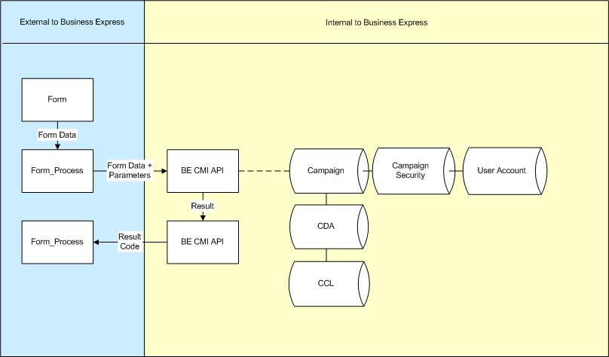

- The external form captures the data.
- The processing page takes the submitted data, adds key parameters to the data and passes it to BE for processing.
- BE receives the data and validates the security. If valid it logs the data.
- BE then generates an identifier code (Successful or Unsuccessful) and returns that to the processing page.
- The processing page interprets the code and displays the result to the user

For step 1 a standard html page is sufficient, the contents of which can usually be generated using the Campaign – External Setup tool provided in BE. Formatting and customisation can be applied as required. A sample of this form is available at http://www.allnone.ie/demo_form.php

If the data you are capturing is of a sensitive nature, you will need to set up an SSL certificate on your webserver.

For step 2 a processing page is required. Sample code for the processing page is provided on the next two pages. A PHP and an ASP example have been provided and are used in the demo processing link above.

These two pages are all that is required to log data in a campaign from a source outside BE.

Data Logging process flow:

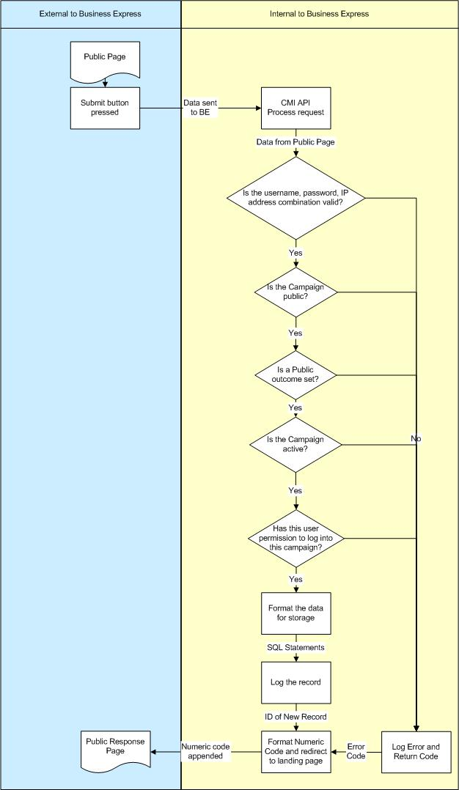
PHP Example

- //=========================================================
- //Data Setup
- //=========================================================

- $url = 'https://ww3.allnone.ie/client/client_demo/cti/userCTI_GenericEntry.asp';

- //set the extrac POST variables required
- $fields = array(
- 'user_id' => urlencode('testing'),
- 'user_key' => urlencode('testing'),
- 'system' => urlencode('formlogging'),
- 'campaignid' => urlencode('56')
- );

- //url-ify the data for the POST
- foreach($fields as $key=>$value) { $fields_string .= $key.'='.$value.'&'; }

- //extract data from the post
- foreach($_POST as $key => $value) {
- $fields_string .= $key.'='.urlencode($value).'&';
- }
- rtrim($fields_string,'&');
- //=========================================================
- //Process Data
- //=========================================================
- //open connection and set the url, number of POST vars, POST data, execute post
- $ch = curl_init();
- curl_setopt($ch, CURLOPT_URL, $url );
- curl_setopt($ch, CURLOPT_POST, 1 );
- curl_setopt($ch, CURLOPT_POSTFIELDS, $fields_string );
- curl_setopt($ch, CURLOPT_FOLLOWLOCATION, 1 );
- curl_setopt($ch, CURLOPT_RETURNTRANSFER, 1 );
- $result = curl_exec($ch);
- curl_close($ch);
- //=========================================================
- //Result management
- //=========================================================
- if (strpos($result,'record>-1<')) {
- $strMessage = 'Sorry but that is an incorrect username or password for logging this record.<br />Please contact the site Administrator';
- } elseif (strpos($result,'record>-2<')) {
- $strMessage = 'Sorry but that is an incorrect IP address to log from that account.<br />Please contact the site Administrator';
- } elseif (strpos($result,'record>-3<')) {
- $strMessage = 'Sorry but that Campaign is not available to the public for storing data in.<br />Please contact the site Administrator';
- } elseif (strpos($result,'record>-4<')) {
- $strMessage = 'Sorry but that Campaign has not been built properly.<br />Please contact the site Administrator';
- } elseif (strpos($result,'record>-5<')) {
- $strMessage = 'Sorry but that Campaign is not active.<br />Please contact the site Administrator';
- } elseif (strpos($result,'record>-6<')) {
- $strMessage = 'Sorry but that user cannot log data in that campaign.<br />Please contact the site Administrator';
- } elseif (strpos($result,'record>-7<')) {
- $strMessage = 'Sorry but no public outcome has been set to process that record.<br />Please contact the site Administrator';
- } elseif (strpos($result,'record>0<')) {
- $strMessage = 'Sorry but no Id was returned.<br />Please contact the site Administrator';
- } else {
- $result = str_replace("<?xml version=\"1.0\" encoding=\"UTF-8\"?>", "", $result);
- $result = str_replace("\n", "", $result);
- $result = str_replace("<record>", "", $result);
- $result = str_replace("</record>", "", $result);
- $strMessage = "The record has been logged with an Id of ".$result.".";
- }
- echo $strMessage;
ASP Example

- '=========================================================
- 'Data Setup
- '=========================================================
- Dim strURL, strData, strFieldName, strFieldValue
- strURL = "https://ww3.allnone.ie/client/client_demo/cti/userCTI_GenericEntry.asp"

- 'set the extrac POST variables required
- strData = ""
- strData = strData & "user_id=" & Server.URLEncode("testing") & "&"
- strData = strData & "user_key=" & Server.URLEncode("testing") & "&"
- strData = strData & "system=" & Server.URLEncode("formlogging") & "&"
- strData = strData & "campaignid=" & Server.URLEncode("56") & "&"

- For Each objItem In Request.Form
- strFieldName = objItem
- strFieldValue = Request.Form(strFieldName)
- strData = strData & strFieldName & "=" & Server.URLEncode(strFieldValue) & "&"
- Next
- strData = left ( strData, len(strData) - 1 )
- '=========================================================
- 'Process Data
- '=========================================================
- 'open connection and set the url, number of POST vars, POST data
- dim xmlhttp, strDataResult, strMessage
- set xmlhttp = server.Createobject("MSXML2.ServerXMLHTTP")
- xmlhttp.Open "POST", strURL, false
- xmlhttp.setRequestHeader "Content-Type", "application/x-www-form-urlencoded"
- xmlhttp.send strData
- strDataResult = xmlhttp.ResponseText
- Set xmlhttp = nothing

- '=========================================================
- 'Result management
- '=========================================================
- if inStr ( strDataResult, "record>-1<") > 0 then
- strMessage = "Sorry but that is an incorrect username or password for logging this record.<br />Please contact the site Administrator"
- elseif inStr ( strDataResult, "record>-2<") > 0 then
- strMessage = "Sorry but that is an incorrect IP address to log from that account.<br />Please contact the site Administrator"
- elseif inStr ( strDataResult, "record>-3<") > 0 then
- strMessage = "Sorry but that Campaign is not available to the public for storing data in.<br />Please contact the site Administrator"
- elseif inStr ( strDataResult, "record>-4<") > 0 then
- strMessage = "Sorry but that Campaign has not been built properly.<br />Please contact the site Administrator"
- elseif inStr ( strDataResult, "record>-5<") > 0 then
- strMessage = "Sorry but that Campaign is not active.<br />Please contact the site Administrator"
- elseif inStr ( strDataResult, "record>-6<") > 0 then
- strMessage = "Sorry but that user cannot log data in that campaign.<br />Please contact the site Administrator"
- elseif inStr ( strDataResult, "record>-7<") > 0 then
- strMessage = "Sorry but no public outcome has been set to process that record.<br />Please contact the site Administrator"
- elseif inStr ( strDataResult, "record>0<") > 0 then
- strMessage = "Sorry but no Id was returned.<br />Please contact the site Administrator"
- else
- strDataResult = replace ( strDataResult, "<?xml version=""1.0"" encoding=""UTF-8""?>", "" )
- strDataResult = replace ( strDataResult, vbCrLf, "" )
- strDataResult = replace ( strDataResult, "<record>", "" )
- strDataResult = replace ( strDataResult, "</record>", "" )
- strMessage = "The record has been logged with an Id of " & strDataResult & "."
- end if
- response.write ( strMessage )
Key Parameters

Line 5: The BE URL which will process the request. Client_demo should be replaced with the name of your system

Line 9: user_id is the username of the account with permission to access the campaign as set up in steps 2.7 and 2.8 of this document
Line 10: user_key is the password of the account with permission to access the campaign as set up in steps 2.7 and 2.8 of this document

Line 11: system is the function to be used, in this case formlogging
Line 12: campaignid is the Id of the campaign to be accessed. This Id is available from Main Menu -> Campaign Management -> Reports - Data Reports -> Campaign – Profile.

Line 38 through 61: These lines can be customised as required as they are simply interpretations of the returned codes.

Appendix A – Response Codes

#000001 = System alive and campaign exists
#000002 = Campaign Id not found
#000002-XXX = Campaign Id not found, - XXX is the campaign id searched for
#000003 = Campaign no longer active – Active Field = False
#000004 = Campaign no longer active – Out of date
#000005 = Invalid Key Field Value
#000006 = Contact record logged successfully
#000007 = Contact record not logged – Id key not found
#000008 = No filename specified to be recorded

End of Document

