PROJECT DEVELOPMENT
All n One Project Development Approach
Overview

This document describes different approaches to project development. We are very experienced in delivering custom client requests so please don’t hesitate to ask for help.
Examples of development approaches include:
- Waterfall development (SDLC - Software Development Life Cycle)
- Incremental development
- Agile development
- Code and fix
- Lightweight methodologies
Traditional approaches work well when there are good definitions of the required processes available. This is not, however, always possible especially when implementing prototypes and concepts. For this reason there is a development approach available in the eLearning arena called ADDIE, which is the one we use for client development.
http://en.wikipedia.org/wiki/ADDIE_Model
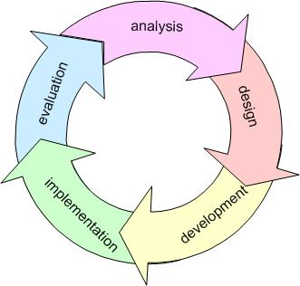

Phased Approach
ADDIE starts with analysis.
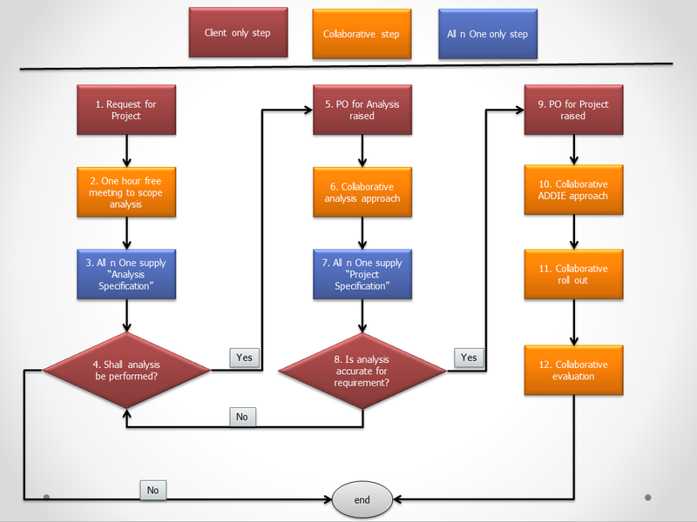
Phase 1.
A client requests a project through one of the support channels.
Phase 2.
One hour free meeting which allows us to familiarise ourselves with the project and understand the key requirements.
Phase 3.
Following the meeting we will create an Analysis Specification document which will provide a timescale for the Analysis phase.
The Analysis phase of any project can significantly change its scope and direction for example because of the light it sheds on current processes, both authorised and unauthorised!
Output 1: Quote for Analysis
Phase 4.
With this initial overview quote in hand the client is in a position to make a far more informed decision as to whether or not to go ahead with a comprehensive analysis.
Phase 5.
Please note that before we undertake any further work on the project we require the client to either issue a purchase order or buy a block of prepaid hours.
Phase 6.
An iterative approach is used to generate the documentation and we provide review points along the way which means that the client is constantly involved.
Phase 7.
We issue the complete analysis document.
Output 2: Analysis Document
Phase 8.
The client is now properly equipped to make a go / no-go decision or, in the light of information produced by the analysis, to revise their initial specification.
Phase 9.
As above, before we undertake any further work on the project we require the client to either issue a purchase order or buy a block of prepaid hours.
Phase 10.
The ADDIE approach is applied across the project to inform timelines and waypoints.
Output 3: Project Documentation
Output 4: Training Documentation

Phase 11.
Roll out. This is a highly is a collaborative stage and requires the extensive involvement of client personnel.
Phase 12.
Evaluation at the end of the process is used to measure the actual Return on Investment of the project. Is it as predicted in the Analysis phase? Evaluation may also lead to further projects but for the purpose of project development it is important to mark and agree an end point to this project.
Output 5: Project Report / Case Study

