Generic Scheduled Reporting Setup

Enabling automated file generation

Customised for: Client Demo

Author: Philip Lacey
Version: 1-2
Date: 2012-02-07

1. Overview

All n One’s Business Express allows for the automated generation of data files through its CMI API. This document details the setup of this automated report generation and the setup required to enable it.

2. Table of Contents

1. Overview 2
2. Table of Contents 2
3. Data capture 3
4. Report setup 3
5. Maintenance File Setup 5
6. Scheduled Task 8
6.1 Step 1. Open the Control Panel. 8
6.2 Step 2. Windows 7 ONLY : Locate and open Administrative Tools 9
6.4 Step 4. Create a new task 10
6.5 Step 5a. Task Configuration for Windows XP 10
6.6 Step 5b. Task Configuration for Windows 7 14
7. SFTP setup 17
7.1 Remote Access 17
7.2 Basic Settings 17
7.3 Show the successful connection 18
7.4 Settings for the site manager 19

3. Data capture

All data entry is done using the Business Express interface. All data is live and available on demand.

4. Report setup

To retrieve the data a Data Profiling group must be set up for the report to be generated.

Training videos on generating Data Profiling groups are available from within the Business Express system.

The report generated to delivery your requirements is

Campaign Id = 1
Report Id = 3

In order to generate a report automatically a user account must be allocated or created with permission to generate the report.

For security the users account will only be able to generate the report from pre-agreed IP addresses. From the server you wish to schedule this report on, access
http://www.allnone.ie/page_help_whatismyip.php

This will give you the IP address from which this machine will access BE and so give you the IP address to allocate to the account.

Armed with the IP address, you can update the Report Generation account.
Below is a snap shot of adding a report generation account to BE, using the System Access management module. Training videos inside Business Express explain how to create a user. The user does not need to be given any access to any module functionality.

The new user account will need security access to the campaign. Training videos inside Business Express explain how to allocate security permissions to campaigns.

Most important is the Primary Security Details section.

IP Range = The IP address just discovered.
External System Id = a username to identify this account externally
External System Key = a keyword to identify this account

With these details set, it is possible to construct the URL. Using the details entered above the URL would be.

https://ww3.allnone.ie/client/client_demo/cti/userCTI_DataProfiling.asp?user_id=reportGenerator&user_key=reprtingKey&ID=1&reportId=3

5. Maintenance File Setup
The most convenient way to execute the report is to create an executable JS (JavaScript) file on the machine that can be scheduled to be run automatically.
Here is the content for that file.
/*-------------------------------------------------------------------
==============================================
Business Express Generic Automated Routine
==============================================
Version 1-0
Date 2012-02-07
Author Philip Lacey
Website http://www.allnone.ie

==============================================
Usage
==============================================
Simply enter the desired URL to execute in the strURL line below.
This script can be scheduled using Task Scheduler
Further support documentation can be found at
http://www.allnone.ie/page_whitepapers.php

-------------------------------------------------------------------*/

var strURL = "https://ww3.allnone.ie/client/client_demo/cti/userCTI_DataProfiling.asp?user_id=abc123&user_key=passkey&ID=123&reportId=123"

/*-------------------------------------------------------------------
==============================================
The following does not need to be modified.
The function creates a Microsoft XMLHTTP object and posts blank to the URL specified.
No feedback is returned via this mechanism.
==============================================
-------------------------------------------------------------------*/
var strMaintenance;
strMaintenance = fn_BEX_PostOrder ( strURL ) ;

function fn_BEX_PostOrder ( strPassed_URL )
{
var xmlhttp = new ActiveXObject ("Microsoft.XMLHTTP");
xmlhttp.Open("POST", strPassed_URL, false);
xmlhttp.Send("");
return xmlhttp.responseXML;
}

Copy and paste the text block above into a text document and save it, adding .js to the end of the filename.

You will need to modify the URL (the text highlighted in orange) to match the report you wish to generate. This URL for this is in the previous Report Setup section of this document.

You should end up with a file icon like

Windows XP | Windows 7
 | 

Here is the constructed file for Client Demo.

/*-------------------------------------------------------------------
==============================================
Business Express Generic Automated Routine
==============================================
Version 1-0
Date 2012-02-07
Author Philip Lacey
Website http://www.allnone.ie

==============================================
Usage
==============================================
Simply enter the desired URL to execute in the strURL line below.
This script can be scheduled using Task Scheduler
Further support documentation can be found at
http://www.allnone.ie/page_whitepapers.php

-------------------------------------------------------------------*/

var strURL = "https://ww3.allnone.ie/client/client_demo/cti/userCTI_DataProfiling.asp?user_id=reportGenerator&user_key=reprtingKey&ID=5&reportId=1"

/*-------------------------------------------------------------------
==============================================
The following does not need to be modified.
The function creates a Microsoft XMLHTTP object and posts blank to the URL specified.
No feedback is returned via this mechanism.
==============================================
-------------------------------------------------------------------*/
var strMaintenance;
strMaintenance = fn_BEX_PostOrder ( strURL ) ;

function fn_BEX_PostOrder ( strPassed_URL )
{
var xmlhttp = new ActiveXObject ("Microsoft.XMLHTTP");
xmlhttp.Open("POST", strPassed_URL, false);
xmlhttp.Send("");
return xmlhttp.responseXML;
}

6. Scheduled Task

Business Express does not assume responsibility for timed requests. This requirement rests with the client, in this case Client Demo.

In order to enable timed requests the client must use Scheduled Tasks within windows to deliver the desired results.

The following screen shots although taken in Windows 7, also apply to Windows XP.

6.1 Step 1. Open the Control Panel

Windows XP | Windows 7
 | 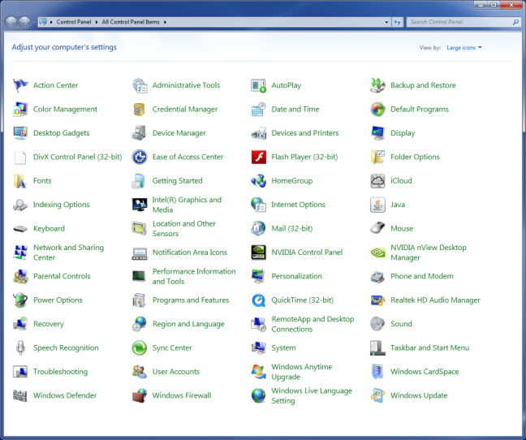

6.2 Step 2. Windows 7 ONLY : Locate and open Administrative Tools

Windows 7
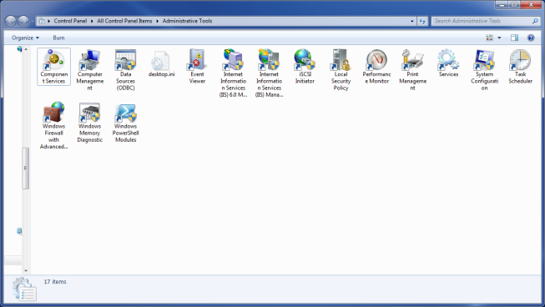

6.3 Step 3. Locate and Open Task Scheduler

Windows XP | Windows 7

6.4 Step 4. Create a new task

Windows XP | Windows 7
The option is entitled “Add Scheduled Task  ” | The option is on the right entitled “Create Basic Task…”  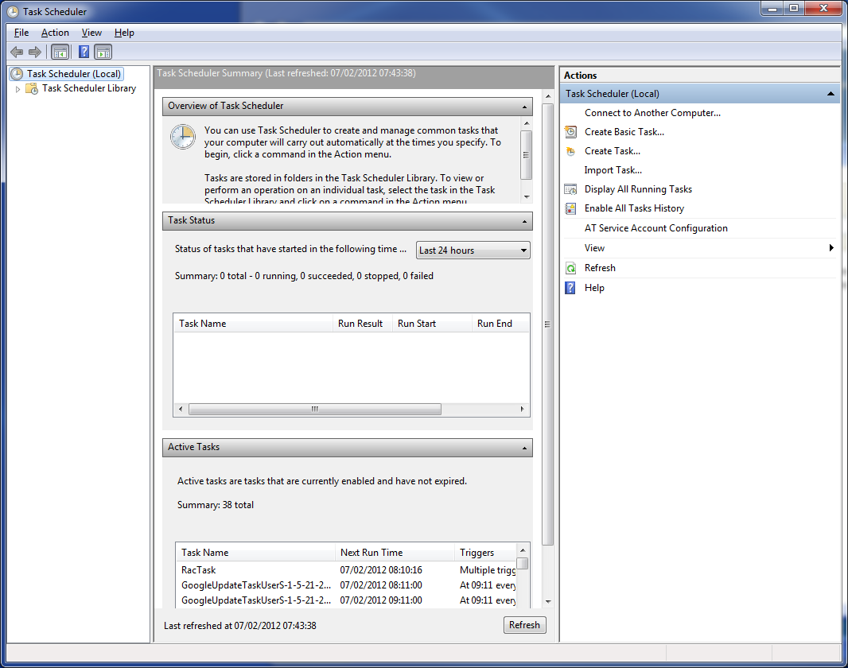

6.5 Step 5a. Task Configuration for Windows XP

Click “Next”

Scroll down and click Browse. Navigate to the JS file you created in the previous section of this document.

Name the task and select how frequently to execute the report. In most cases this will be daily.

Set the time to execute the report

In Windows XP, you will need to set the username and password of the Windows XP account that can be automated

Ensure the “Open advanced properties for this task when I click Finish” is NOT ticked. Then click Finish

6.6 Step 5b. Task Configuration for Windows 7

Name the task

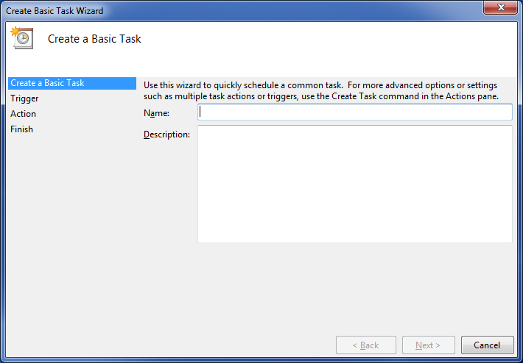

Set the timing period required to run the reports

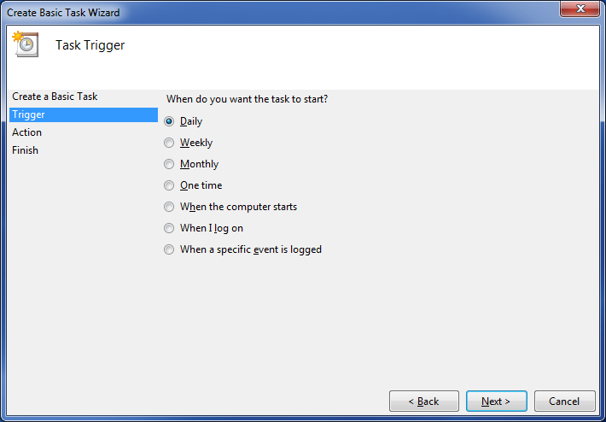
Set the time the report will run and then click Next

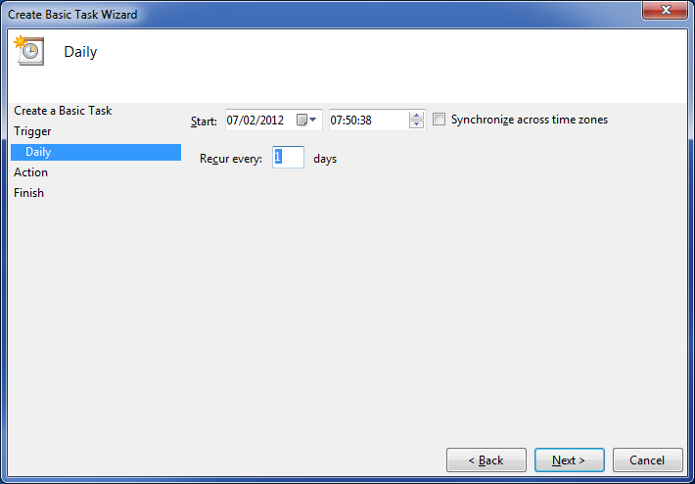

Choose “Start a program” and click next

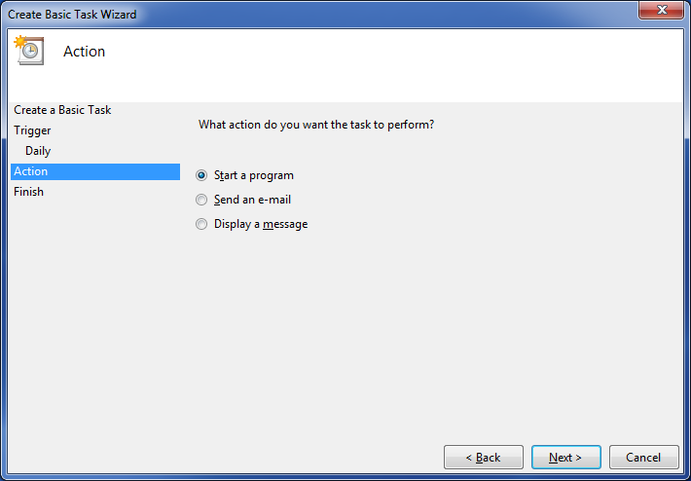

Click the browse button and navigate to the JS file you created in the previous section of this document.

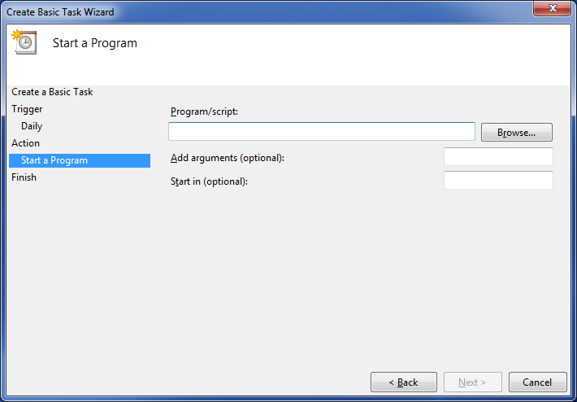

Click Finish.

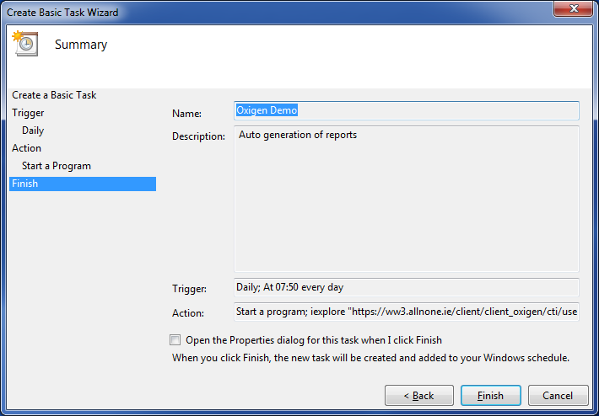

7. SFTP setup

7.1 Remote Access

Retrieving of files can be done a number of ways. SFTP is one of these ways.

This is usually done using a secure FTP client such as FileZilla.

http://filezilla-project.org/



7.2 Basic Settings

Host: 82.195.135.248

Username: ftpdemo

Password: --will be communicated separately—

Encryption: Require explicit FTP over TLS

Transfer Model: Passive

7.3 Show the successful connection
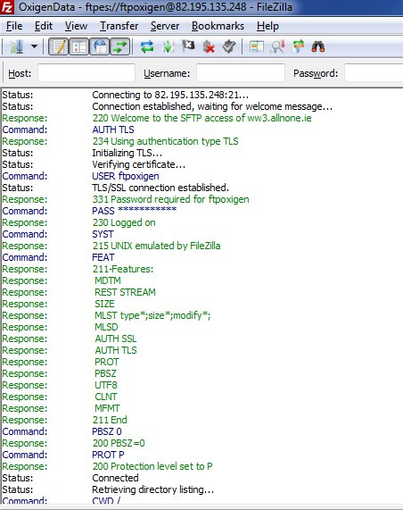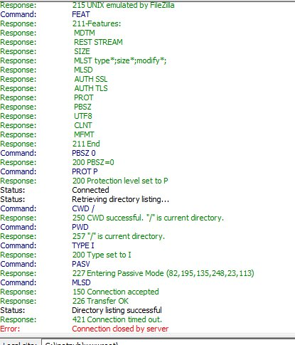

7.4 Settings for the site manager

