Project: Integrated Warehousing

Dealing with large reporting queries

Author: Philip Lacey
Version: 1-0
Date: 2010-10-11

Overview

All n One’s Business Express provides data to reports in real time. This allows for useful reporting in real time. When the Data Profiling reporting functionality is used, it is possible to pull reports containing hundreds of thousands, even millions of records. These large reports are traditionally handled by Data Warehouses, with information traditionally provided in batch, with a lag on availability of information. Business Express now contains an integrated solution which provides the large stability of a warehouse, with the real time functionality of an operational reporting system, without system delay.

Campaign Overview

Campaign data is held in two tables. A CDA or Campaign DAta table, which contains the static permanent information and a CCL or Campaign CaLl table which contains contact information, for every interaction with the record. Between these two tables all information for the reports in Business Express is generated.

Reports come from two sources, the Campaign Management and Data Profiling modules. The Campaign management module reports are heavily scripted and as such allow for complex database indexes to be applied to the data, to ensure reports always run quickly.

Data Profiling, by its nature, is not pre-scripted. The results in reports taking far longer to generate and return data results. Whilst every programming effort is made to automate the generation of the reports and most reports do generate quickly (i.e. 100,000 records is pulled in < 4 minutes), some complicated non-optimised reports can take upwards of two hours to generate.

Challenges

What happens if a large data report is pulled during the middle of the operational day?

This creates an operational headache. When a large report is pulled on the CDA and CCL tables, the tables become locked into providing the information to the report, at the expense of all other operational processes. If a large data profiling report is started, this can prevent new records from being added to the CDA and CCL tables. In instances where records are looked up, it can prevent the record from displaying. To combat this, this project provides an anti-locking mechanism.

How can Data Profiling reports be sped up?

There are two options to speed up reports. By tweaking the parameters of the query, the selection process by the database can be sped up. The other option is to add Indexes to the data for frequently used data fields. Both of these options require some knowledge of the systems, reports and are available through support from All n One.
Anti-Locking Mechanism

To prevent locking Business Express has implemented integrated warehousing.

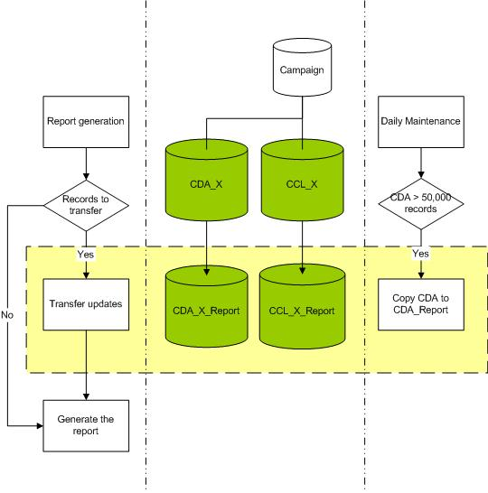

As part of the daily maintenance routine BE will check to see if a campaign has exceeded 50,000 records. If it has, then integrated warehousing will be enabled automatically on the campaign.

As part of the daily maintenance routines, BE will perform an automatic update on all integrated warehouse tables, to copy the CDA and CCL updates to the CDA and CCL report tables.

As and when data profiling reports are run, any changes to the CDA or CCL tables are copied into the new CDA and CCL report tables. This ensures the data in the report tables is always as up to date as the operational tables.

If a large locking report is run, this will not affect the operational tables. Extra indexes can be applied to the Report tables, as well, to speed up queries. This extra indexing will be applied by BE support staff.

