Adding Questions to the form in bxp

Step 1. Click on form management on the modules bar at the bottom of the screen

Select primary form management from the list

Click on form Edit

From the list select the form that you want to edit then hit select

To the left of the screen there is a menu with Blue, green, and purple buttons like so
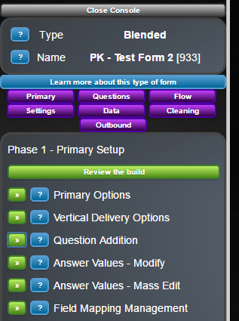

On this panel click

Step 2.

Once clicked you will see the following screen

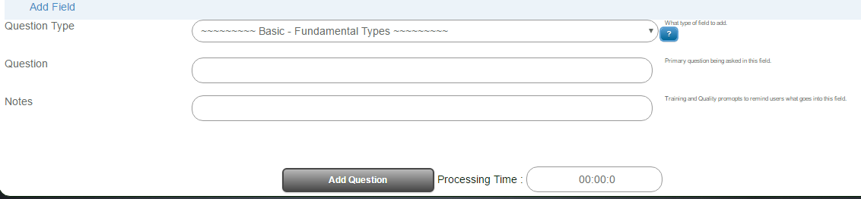

On this page for question type click the drop down menu and select the type of Question box you want

For Question type enter the text you want the user to see on the form i.e. First name, address etc.

Remember you can type anything you want here and it will be visible on the form

Once done click on Add Question

Then click Review the build to see the effect

Do this each time for whichever number and type of questions you require

STEP 3.

Click on questions from 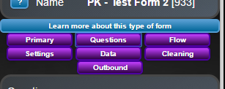

On the menu that appears go to

A screen will appear showing the list of all questions on the phone like so

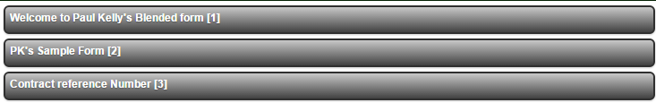
Step 4.

It is now a case of latterly working out where you want the Question to appear on your form
Then drag and drop it where you need it to be

Note for questions that appear inside dropdown sections the positioning is important

http://www.bxpsoftware.com/wixi/index.php?title=Form_-_Field_Mapping_Management

Go to the Wixi button on your home screen and enter Form in the search box this will list all articles relating to the creation, styling, and management of forms in bxp

