Clearing the Be-Mail Stack

Introduction

Executive Summary

Steps required to clear the stack on Be-Mail

stakeholders

All n One

Initial Name Company Role Email Address
NW Nick Wheeler All n One Ltd CEO nick.wheeler@allnone.ie
CT Chris Thomson All n One Ltd COO chris.thomson@allnone.ie
PL Philip Lacey All n One Ltd CTO philip.lacey@allnone.ie
CD Carolann Diskin All n One Ltd Technical Ops Manager carolann.diskin@allnone.ie
DC Daniel Coughlan All n One Ltd Snr. Framework Developer daniel.coughlan@allnone.ie
PJ Patrick Jenkins All n One Ltd Snr. Content Developer patrick.jenkins@allnone.ie
ML Meabh Landers All n One Ltd Content Developer meabh.landers@allnone.ie
AF Andrew Forde All n One Ltd Technical Contact Admin andrew.forde@allnone.ie
TG Thomas Glennon All n One Ltd Security Administrator thomas.glennon@allnone.ie
RC Robert Carson All n One Ltd BDM & Infrastructure Admin robert.carson@allnone.ie
PK Paul Kelly All n One Ltd Jr. Content Developer paul.kelly@allnone.ie
JR Jason Ryan All n One Ltd Infrastructure Jason.ryan@allnone.ie

Version History

Version | 1-0
Date | 2016-08-09
Author | Paul Kelly

Step One
- Go to Outbound contact Go into Outbound contact 
- Go into Queue Management
- Click View Contact Queue
- Select the campaign you want
- You will see the following
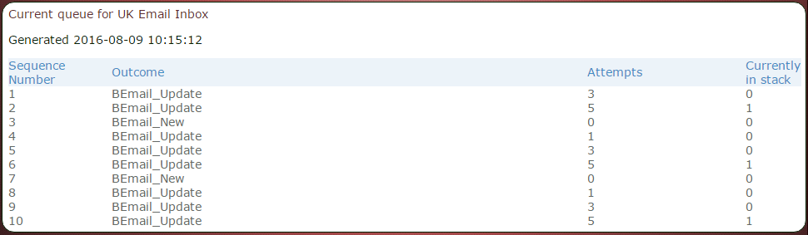
- Go back to Queue management
- Click clear the contact Queue
- Select the campaign
- Click Reset the Queue
- Go to Outbound contact
- Go into Queue Management
- Click view Contact Queue… (this should now be clear thus removing the block)
- Go Back into Outbound contact
- Click on Queue Management
- Click on set current Working Outcome
- Select the campaign
- Hover over BE-Mail new and Click

