Dublin Software Company Land Prestigious Business Accolade
_____________________________
bxp software Named Business All-Star Customised Software Solutions Company 2022
---------------------------------------------------
Dublin based software company bxp software have achieved Business All-Star Accreditation from the All-Ireland Business Foundation.

Formed in 2005 bxp software proudly develop solutions that resolve specific challenges for a range of clients, including Bank of Ireland, Virgin Media, Mater Private, One4All, eir, Greyhound Recycling, Fexco, Aware, ACOI and many more. The specifics of these builds have ranged from simply replacing a process that has become spreadsheet reliant and is no longer fit for purpose, to more intricate solutions that can integrate with legacy software or indeed replace it altogether.
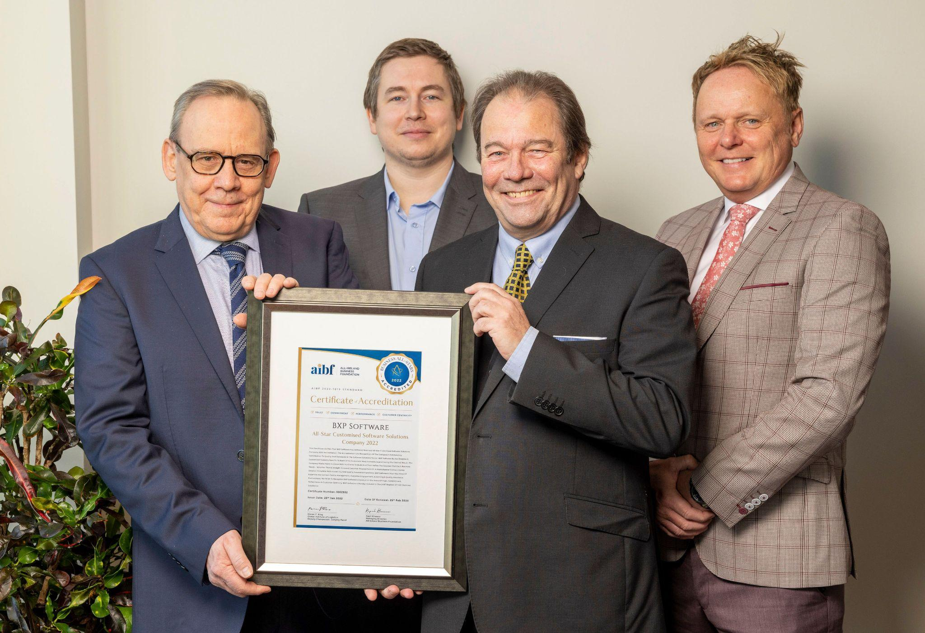
Pictured L-R: Chris Thomson, COO, Patrick Jenkins, CTO, Nick Wheeler, CEO,
& Aiden Rice, Commercial Director photographed with their All-Star Accreditation certificate.

bxp software has been named All-Star Customised Software Solutions Company 2022 in recognition of the company’s outstanding contribution to quality and standards in the software solutions sector.
bxp perceive three key differentiators between themselves and other software solution providers.
Custom-built
Every solution is customised to the precise specifications of the client. We shape the system around these needs, as opposed to forcing the client’s processes into a pre-built (off-the-shelf) product.

Integration
Often, our client relationships start out with a lightweight, tactical solution that resolves a specific challenge and then develops into a business-wide solution that might encompass process-flow, CRM, management reporting and integration with legacy software including telephony, database, and accounting packages.

Partnership
From the outset, bxp create an atmosphere of partnership rather than Client and Supplier. To us, this is essential because, as the system is adopted across the organisation, it becomes a vital strategic tool and for this, absolute trust and reliability is essential.

Business All-Star Accreditation is an independently verified standard mark for indigenous businesses, based on rigorous selection criteria. The Accreditation is overseen by the prestigious All-Ireland Business Foundation, whose adjudication panel is chaired by Dr Briga Hynes of the University of Limerick and Kieran Ring, CEO of the Global Institute of Logistics.

Reacting to the announcement, bxp software Commercial Director Aiden Rice said:
“We are delighted and proud to be named Business All-Star Customised Software Solutions Company 2022. The achievement recognises our outstanding contribution to quality and standards in the software solutions sector as well as our conduct in the areas of trust, commitment, performance & customer-centricity. It’s always a positive to be recognised for your work, but we see this particular honour as being at a different level.”

“Business All-Star Accreditation is based on the independently sought opinions of our clients, which means that it is founded on the real experiences of live customers. The variety and standard of AIBF accredited businesses tells its own story, as does the AIBF’s standing with universities, government ministers and other national bodies. This accreditation will underline the trust that our clients place in our service and it will give confidence to those who are just starting out on their bxp journey. If your own organisation has a process that requires automation or streamlining, we would be delighted to show you what is possible when you partner with bxp software.”

Deputy Chair on the Adjudication Board Kieran Ring, said in support of the announcement:
“bxp software has achieved Business All-Star Customised Software Solutions Company 2022 Accreditation. The accreditation is in recognition of the company’s outstanding contribution to quality and standards in the software solutions sector. Furthermore, we wish to recognise bxp software’s conduct in the areas of trust, commitment, performance & customer-centricity. bxp software is hereby included in the AIBF Register Of Irish Business Excellence.”

Managing Director of the All-Ireland Business Foundation Kapil Khanna said
“the accreditation, which is now held by over 500 firms, is needed by the thousands of small and medium businesses which operate to their own standards but have nothing to measure them by.
He said: “We evaluate a company’s background, trustworthiness and performance, and we speak to customers, employees and vendors. We also anonymously approach the company as a customer and report back on the experience. The business goes through at least two interviews and is scored on every part of the process against set metrics.”

The All-Ireland Business Foundation (AIBF) is an autonomous national accreditation body tasked with enterprise development and the promotion of Best-in-Class in Irish business.

The Foundation actively engages and supports its network through peer dialogue, collaboration, mentoring and enterprise development activities. Companies are qualified for accreditation by completing an enterprise audit and are identified by their use of the AIBF’s Business All-Star Marque.

AIBF PRESS CONTACT BXP SOFTWARE CONTACT
Cathal Austin Aiden Rice
Communications & Press Officer | AIBF Commercial Director
media@aibf.ie / 0864508558 0868675554

